**MEDICAL INVENTORY MANAGEMENT**

College Name: Sri Ramakrishna College of Arts and Science for Women

College Code: Bru28

**Team ID: NM2025TMID24205**

**Team MEMBERS:**

**TEAM LeaderName:** Harini.K

**Email:** [srcw2322k114@srcw.ac.in](mailto:srcw2322k114@srcw.ac.in)

**Team MEMBER1:** Ishwarya.S

**Email:** [srcw2322k116@srcw.ac.in](mailto:srcw2322k116@srcw.ac.in)

**Team MEMBER2:** Dharshini.S

**Email:** [srcw2322k110@srcw.ac.in](mailto:srcw2322k110@srcw.ac.in)

**Team MEMBER3:** Harini.V

**Email:** [srcw2322k115@srcw.ac.in](mailto:srcw2322k115@srcw.ac.in)

**1.INTRODUCTION**

**1.1 Project Overview**

This project is a comprehensive Salesforce application to streamline and manage various operational aspects of medical inventory. The system aims to efficiently maintain supplier details, manage purchase orders, track product details and transactions, and monitor the expiry dates of products. Maintain detailed records of suppliers, including contact information. Catalog product information, including descriptions, stock levels. Monitor and track product expiry dates to avoid using expired items. Comprehensive reports to track supplier performance, and purchase orders**.**

**1.2 Purpose**

The purpose of medical inventory management is to ensure that hospitals and healthcare centers always have the right medicines, equipment, and supplies available when needed. It helps prevent shortages, avoid the use of expired items, and reduce wastage. By controlling costs and maintaining accurate records, it supports smooth hospital operations while ensuring patient safety and quality care.

**DEVELOPMENT PHASE**

**Creating Developer Account:**

By using this URL -<https://www.salesforce.com/form/developer-signup/?d=pb>

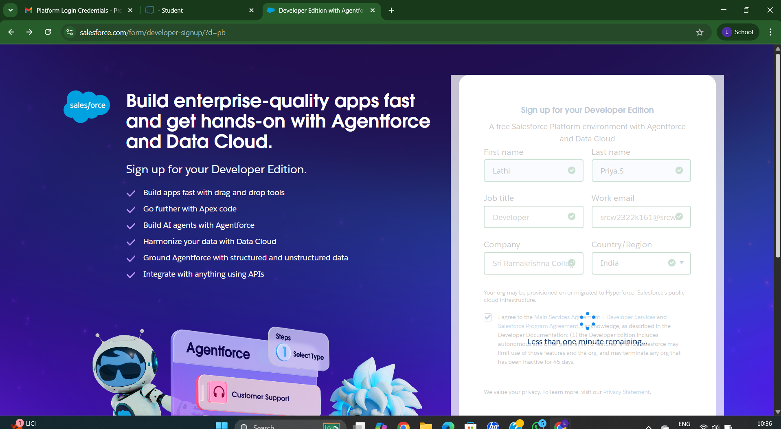

**Creating Objects :Product, Purchase Order, Order Item, Inventory Transaction, Supplier**

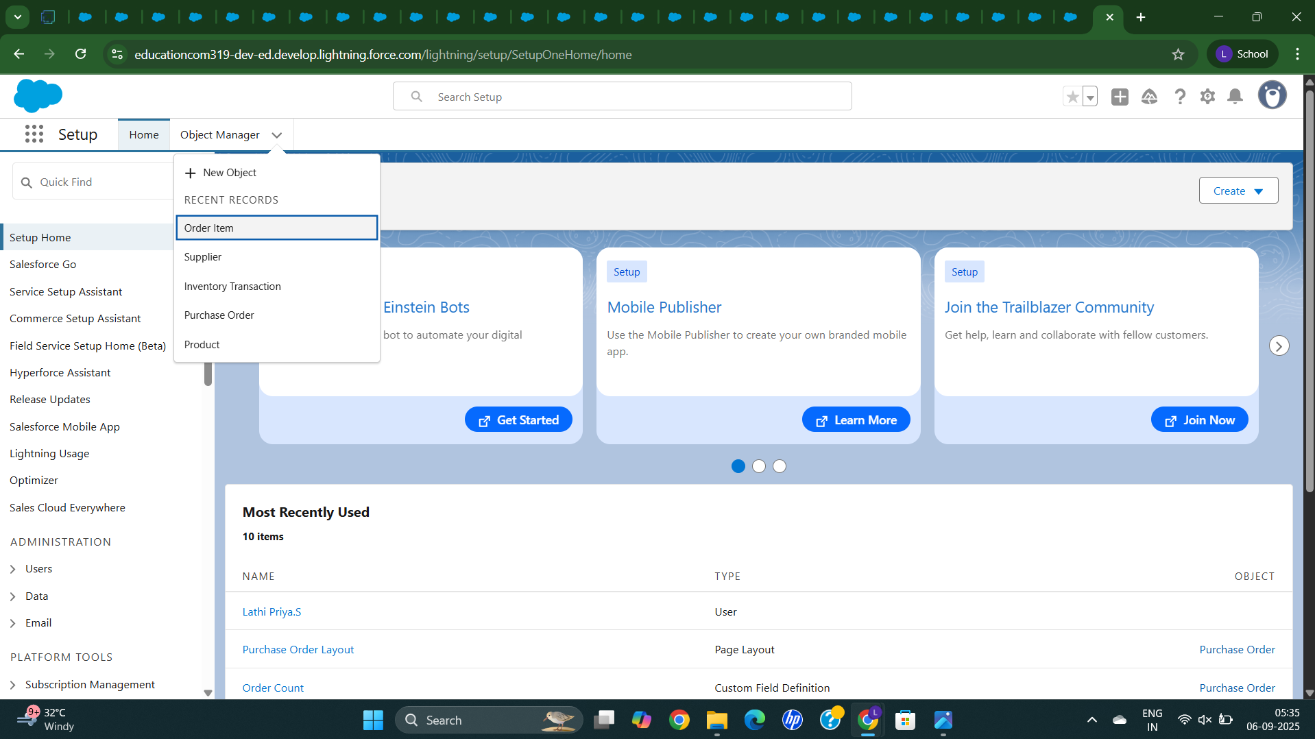

**Creating a Tabs for Product, Purchase Order, Order Item, Inventory Transaction, Supplier**

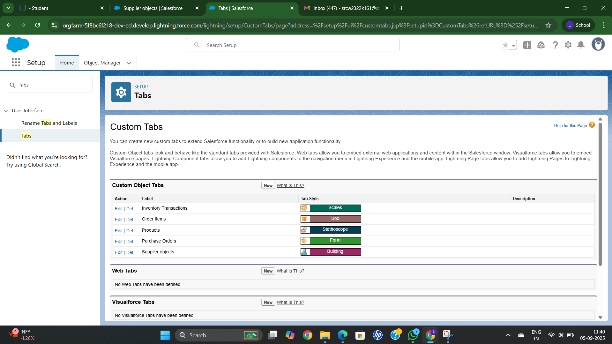

**Creating a Lightning App for Medical Inventory Management**

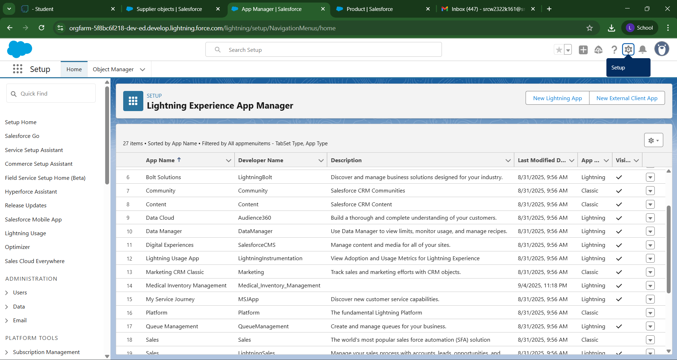

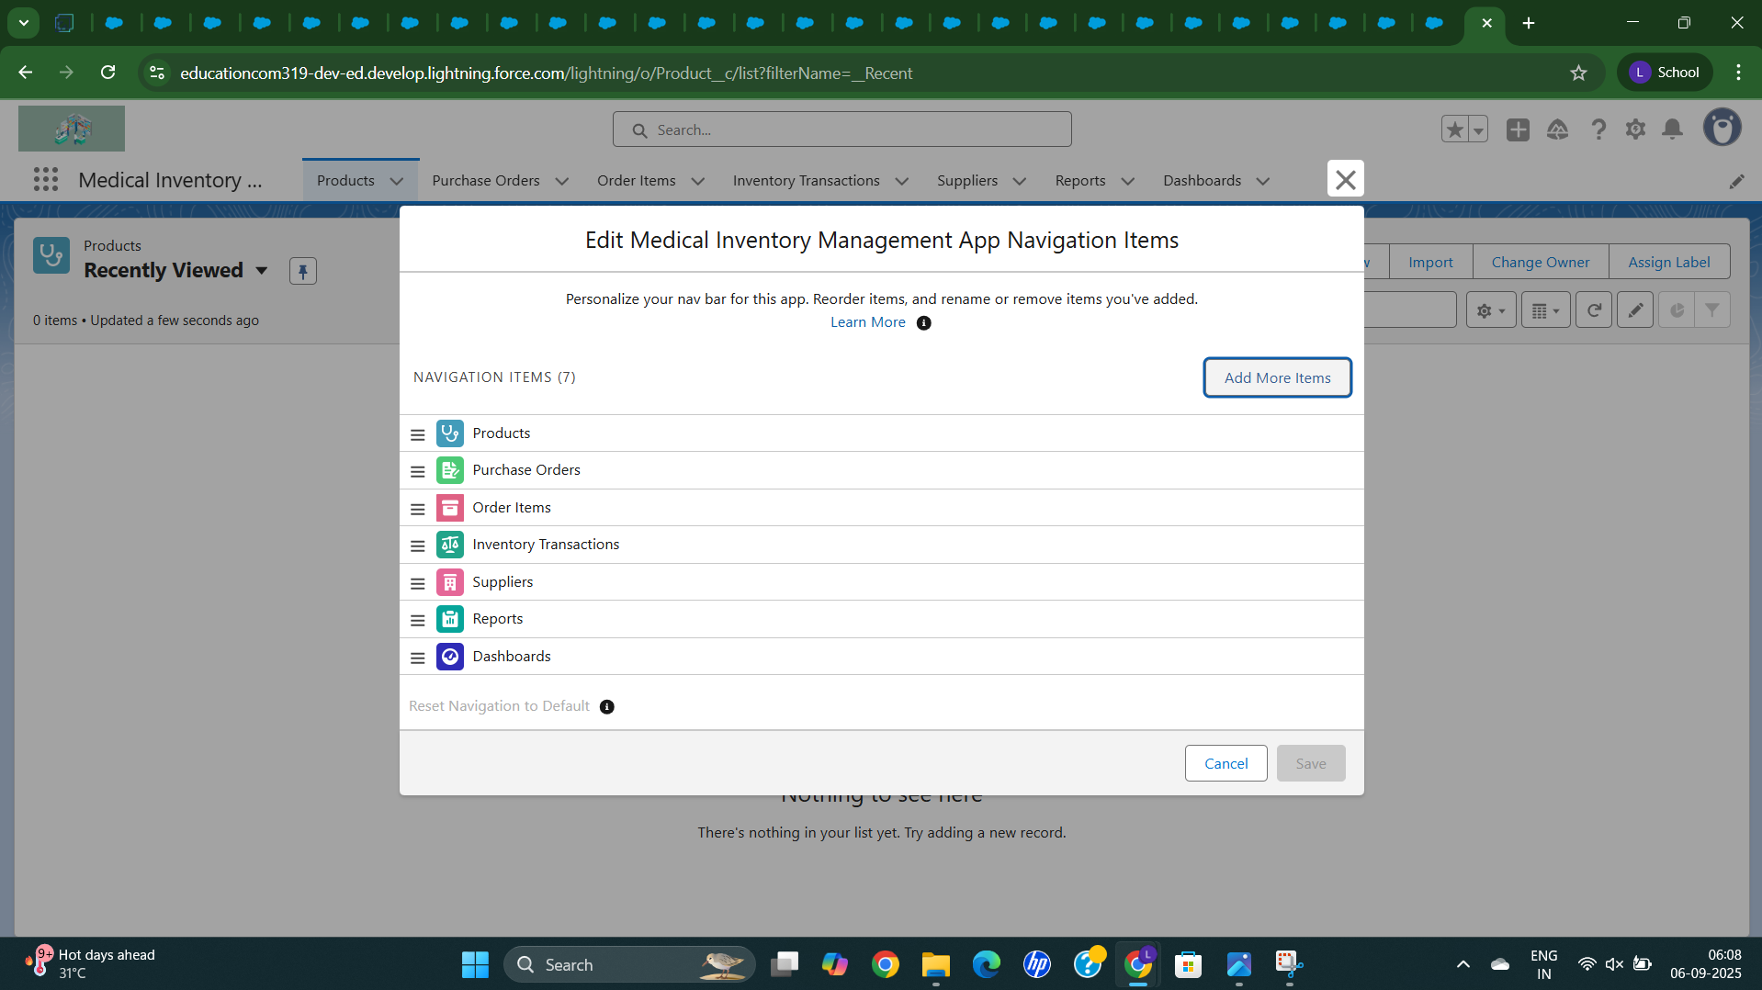

**Creating a field for Product**

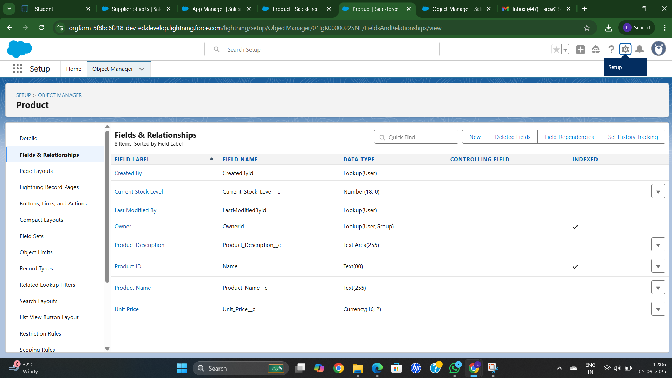

**Creating a field for Purchase Order**

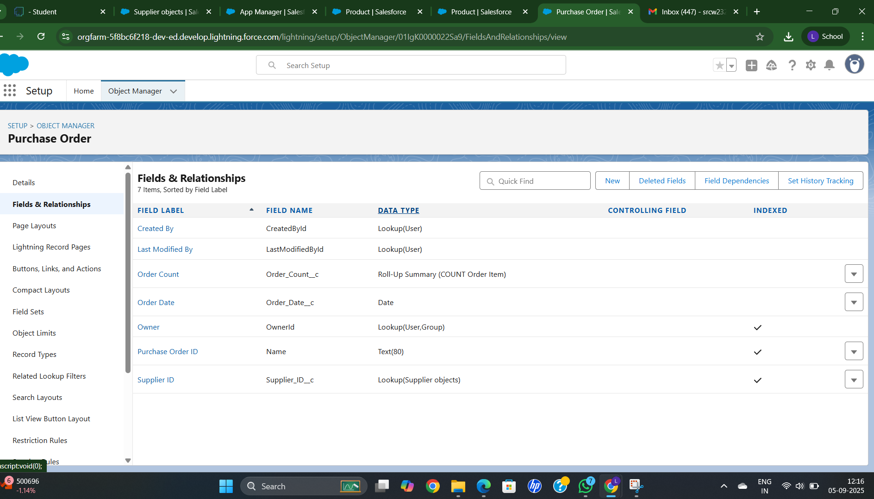

**Creating a field for Order Item**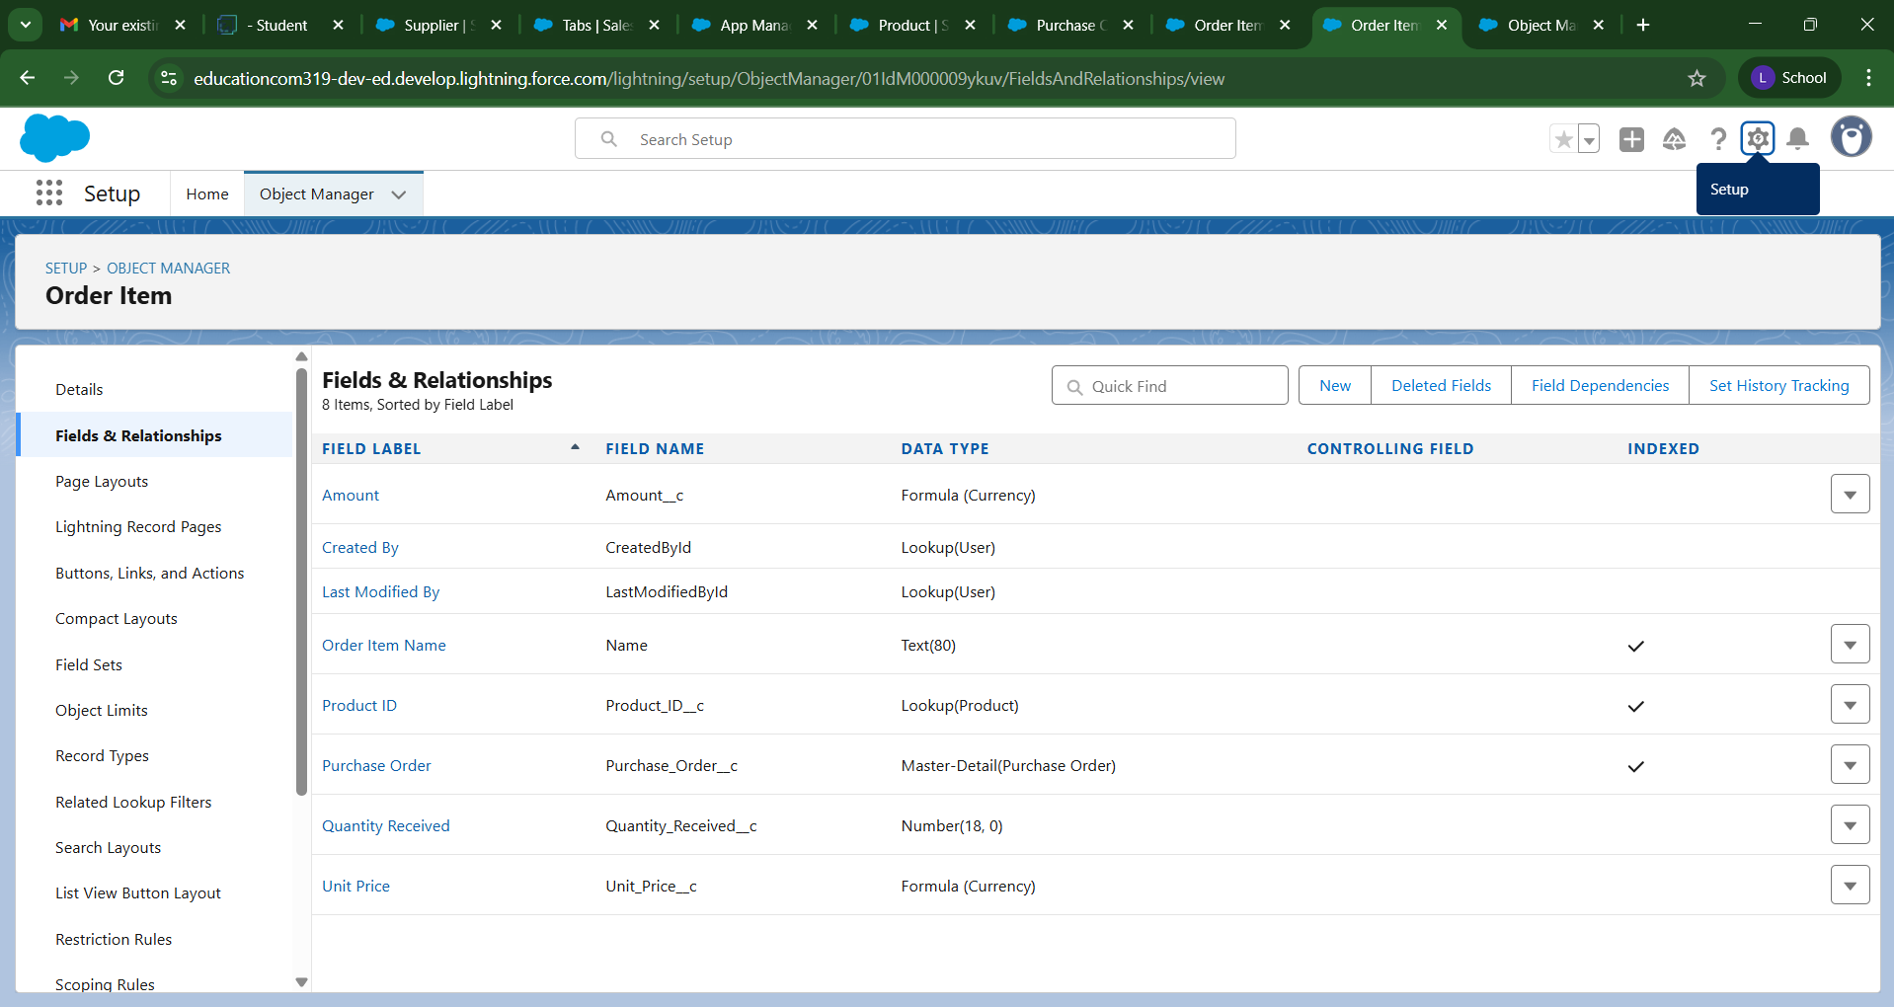

**Creating a field for Inventory Transaction**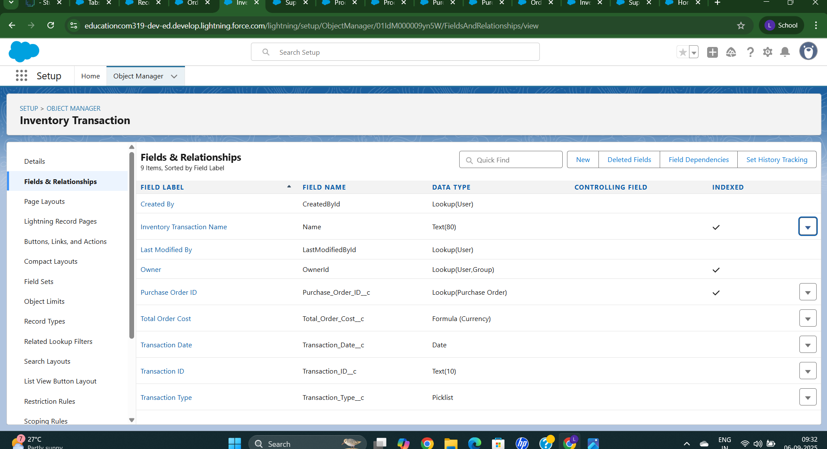

**Creating a field for Supplier**

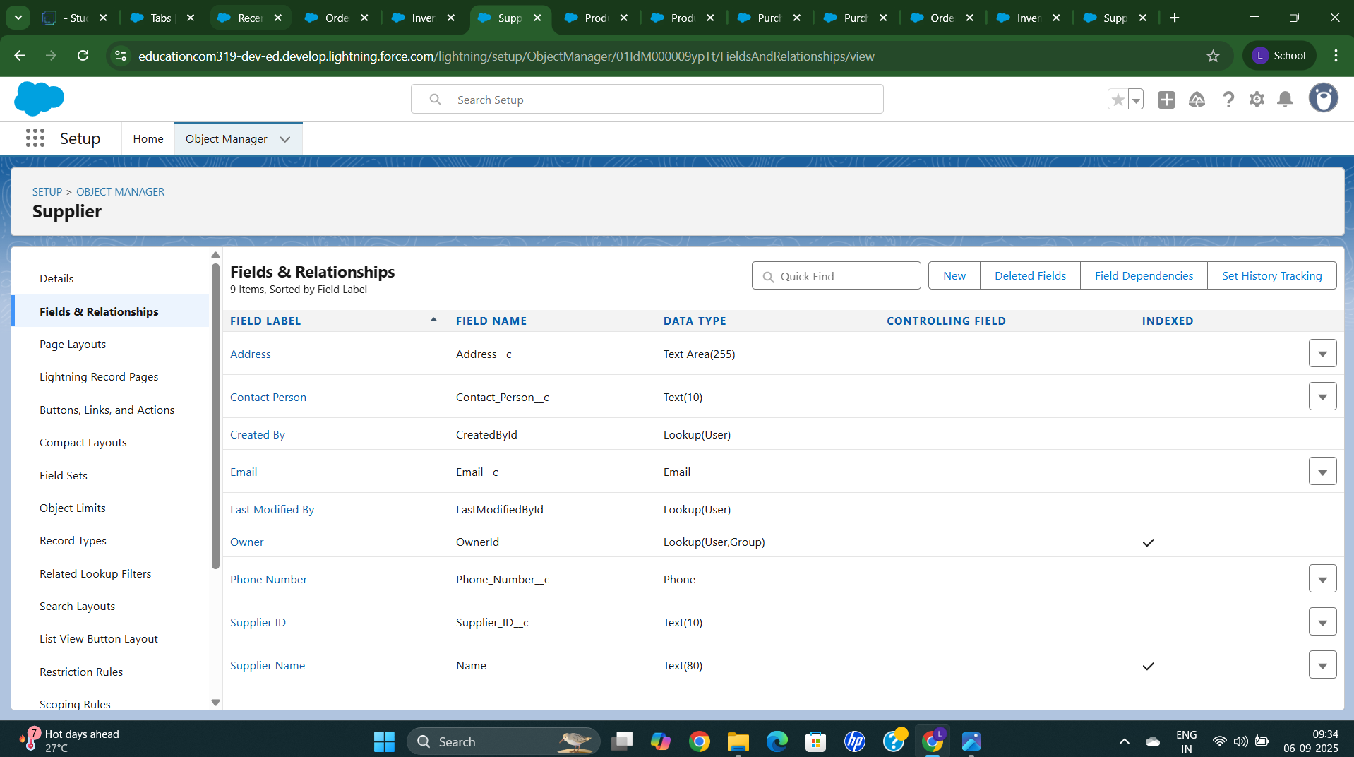

**Editing a Page Layout for Product**

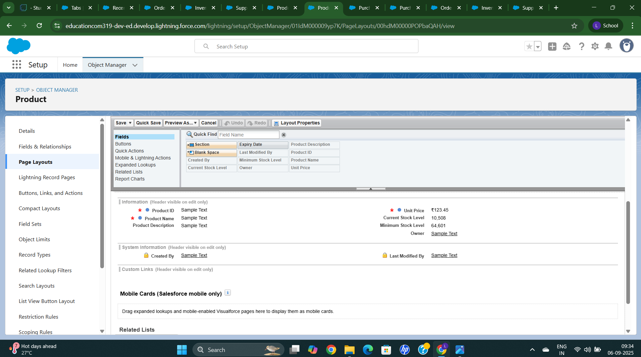

**Editing a Page Layout for Purchase Order**

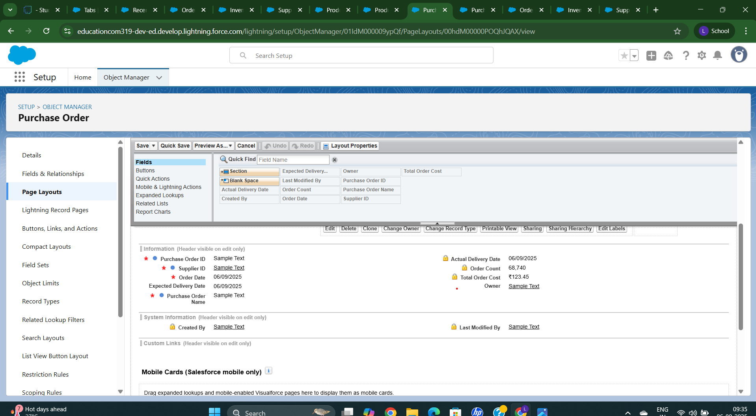

**Editing a Page Layout for Order Item**

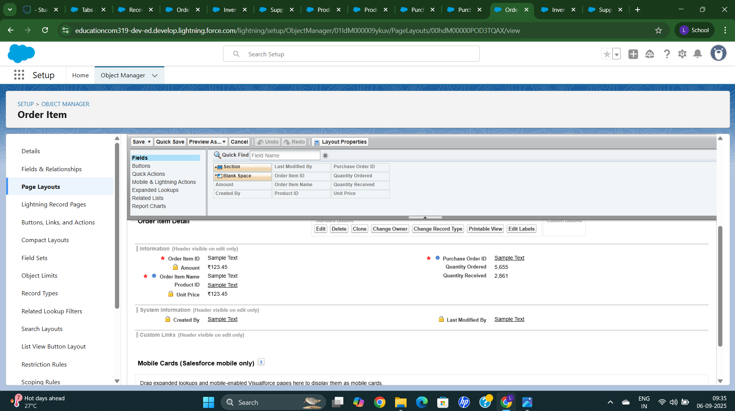

**Editing a Page Layout for Inventory Transaction**

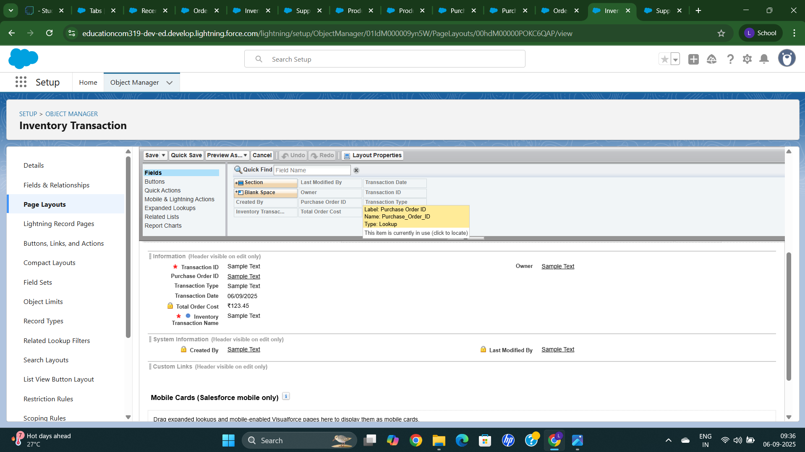

**Editing a Page Layout for Supplier**

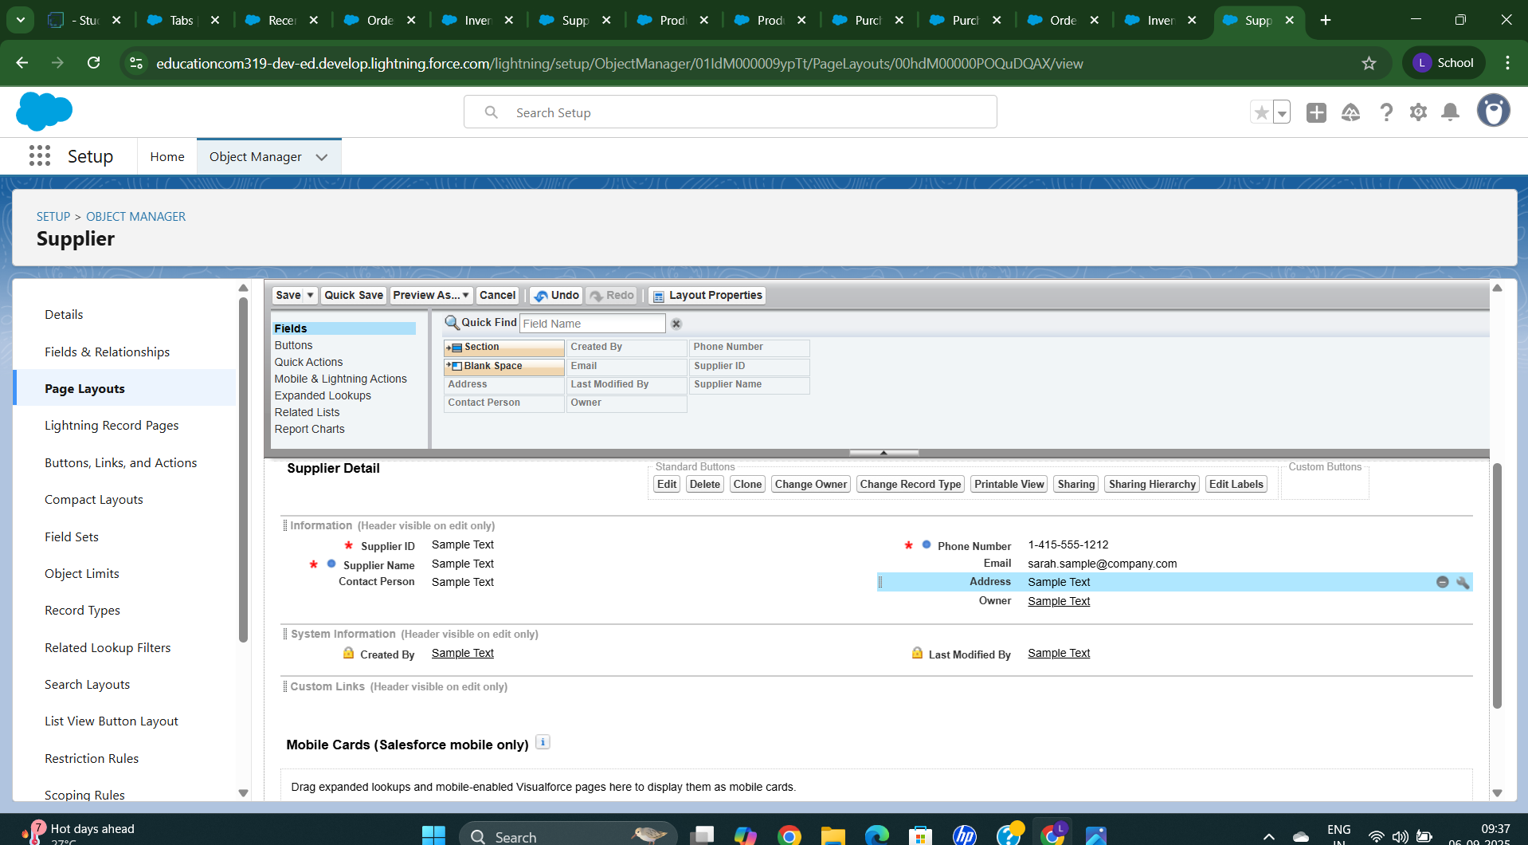

**Create a Compact Layout for a Product Object**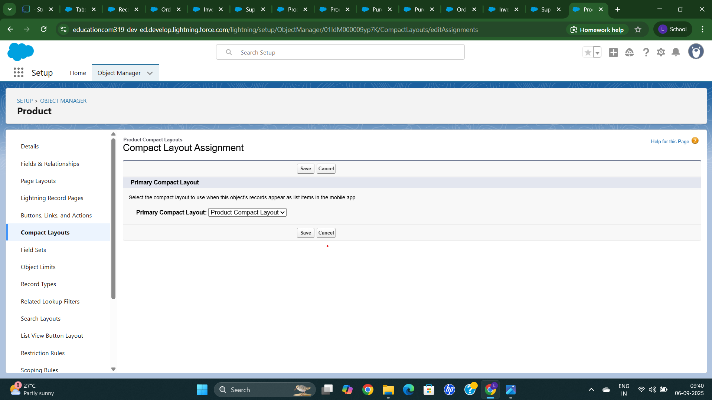

**Create a Compact Layout for Purchase Object**

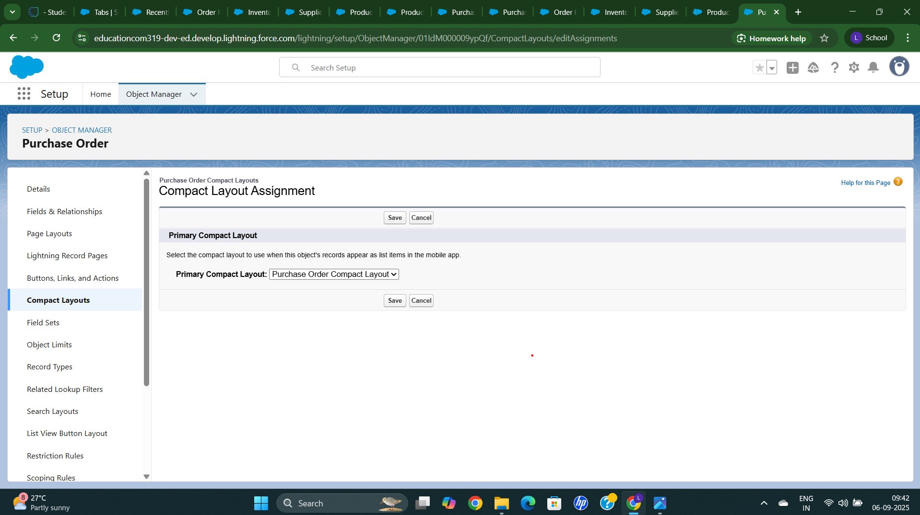

**Create a validation Rule for Employee in Purchase Object**

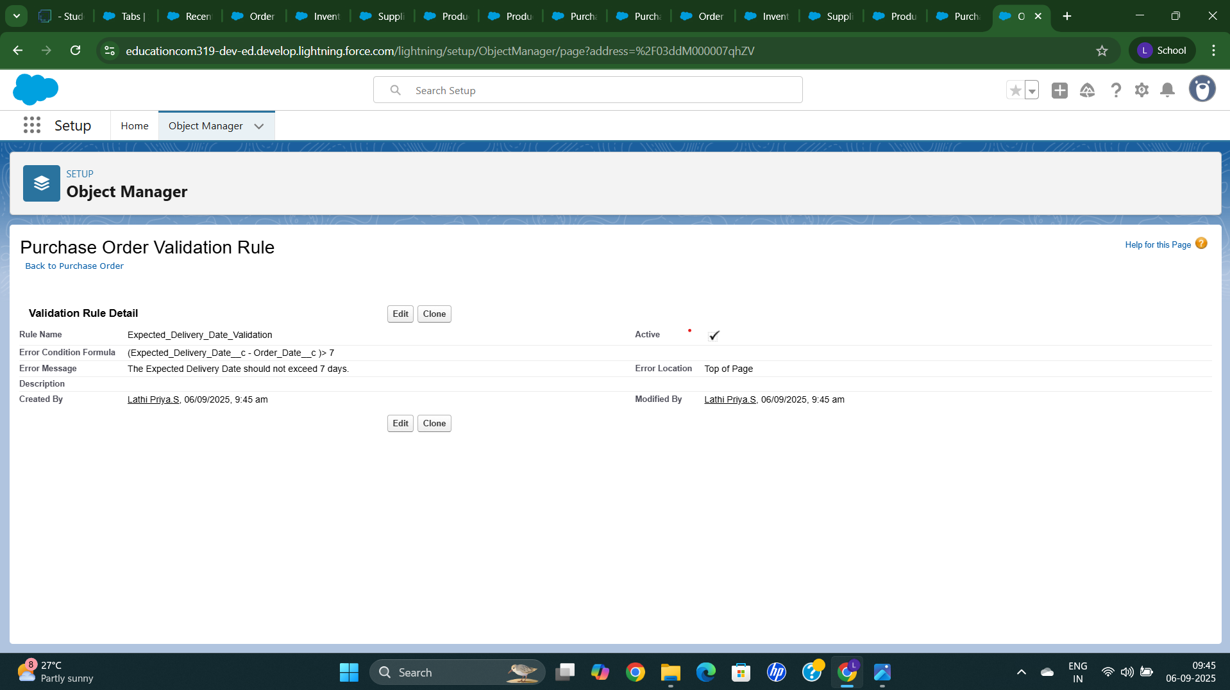

**Create a Profile for Inventory Management**

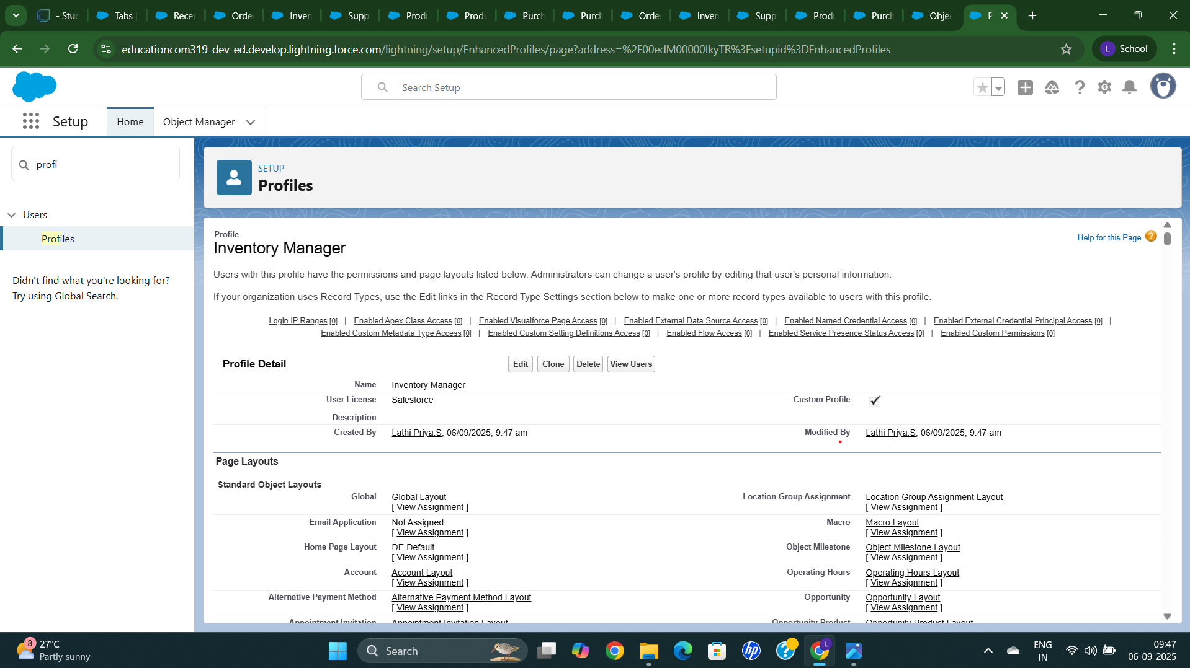

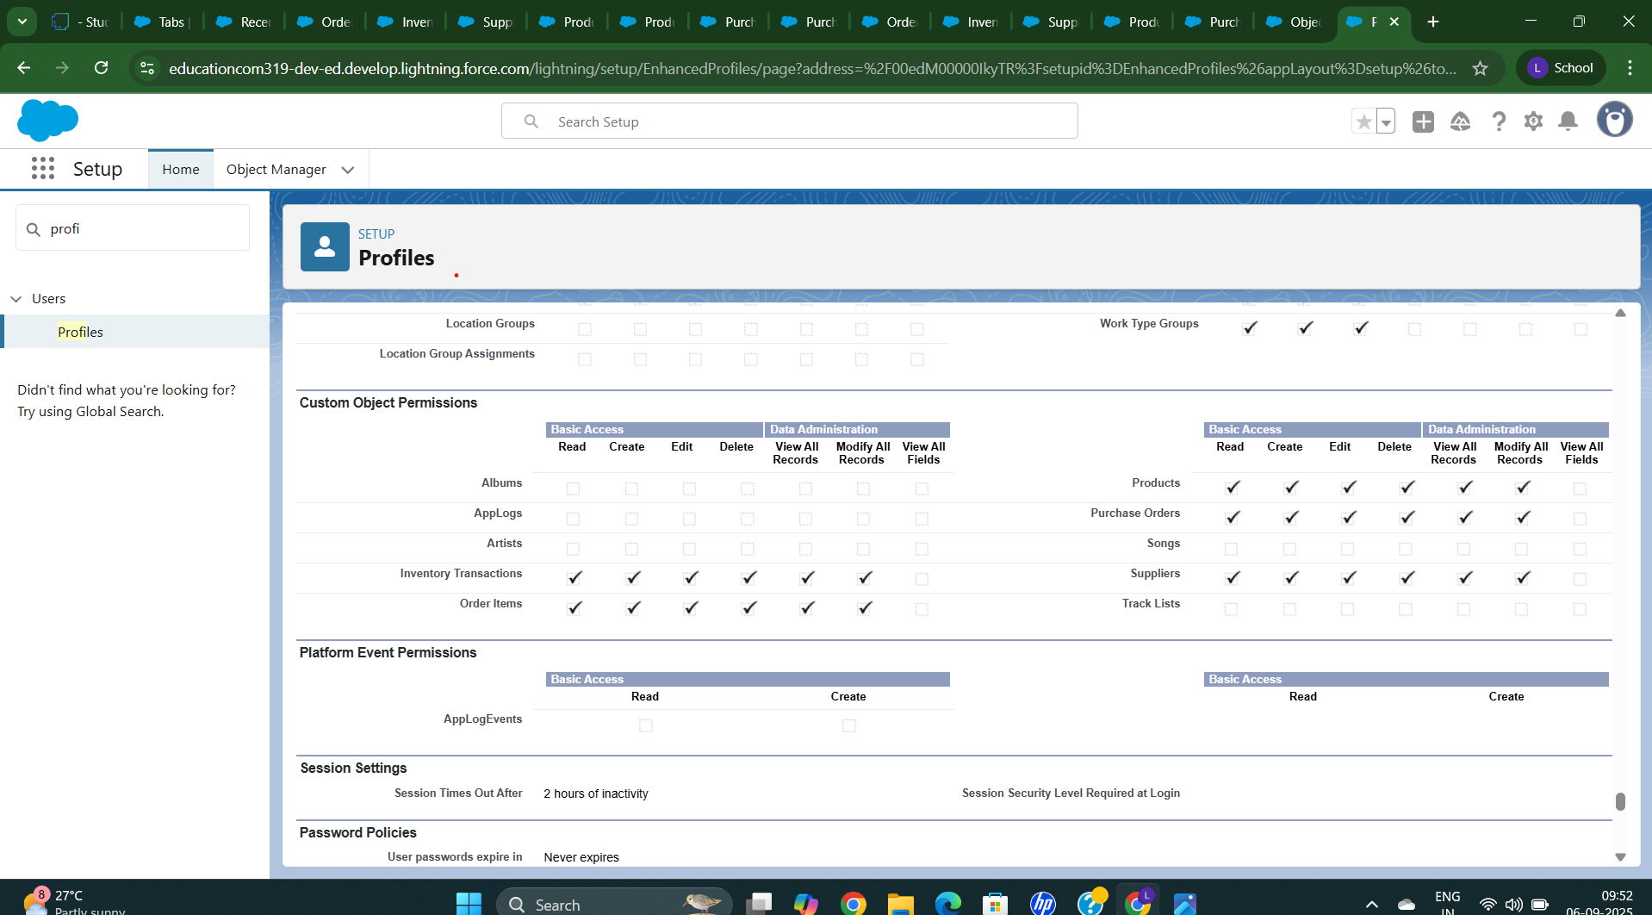

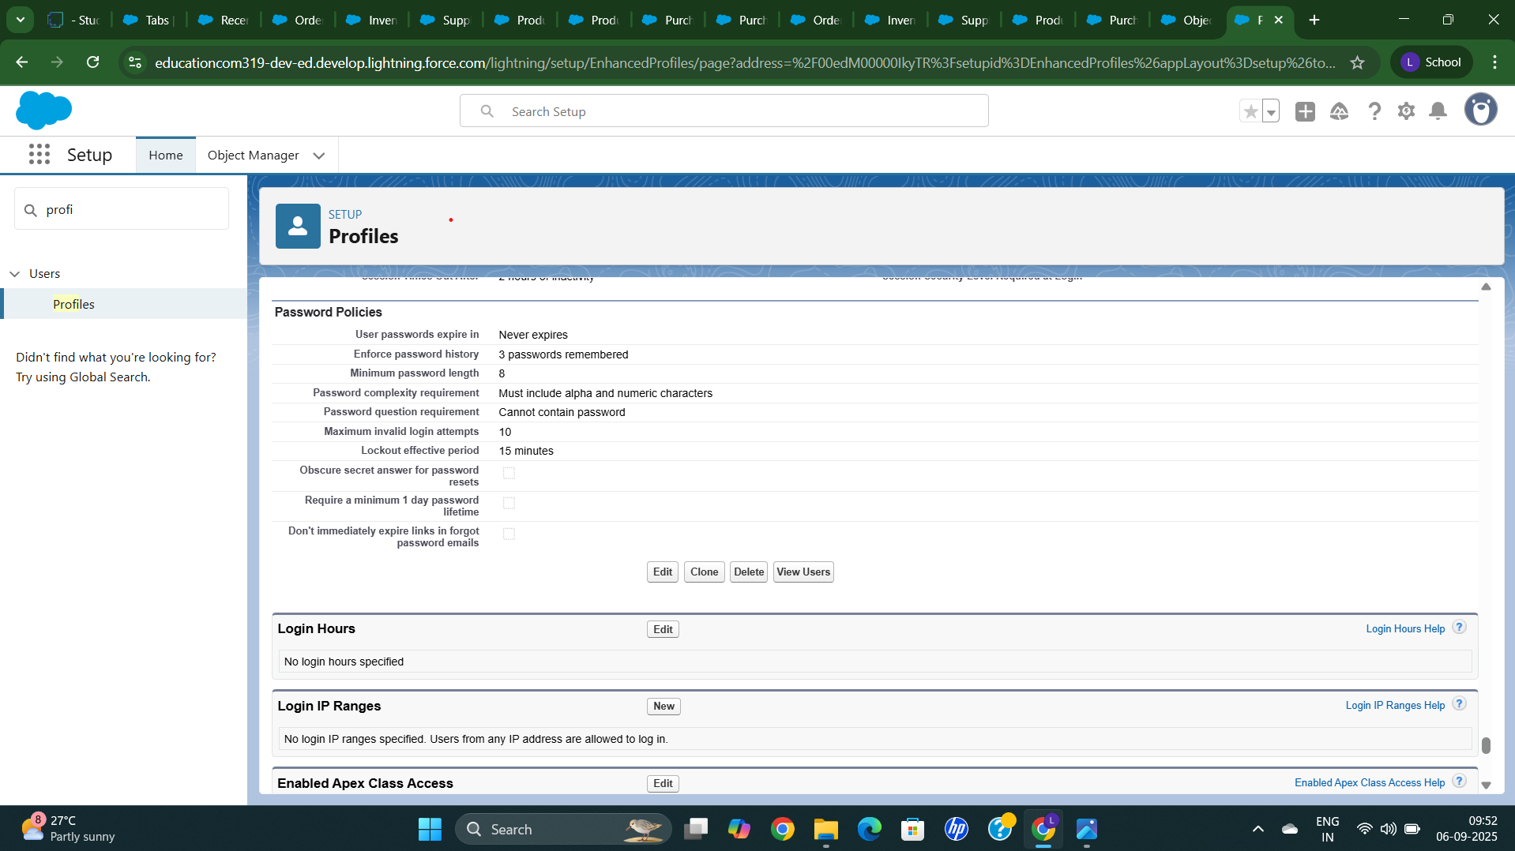

**Create a Profile for Purchase Object**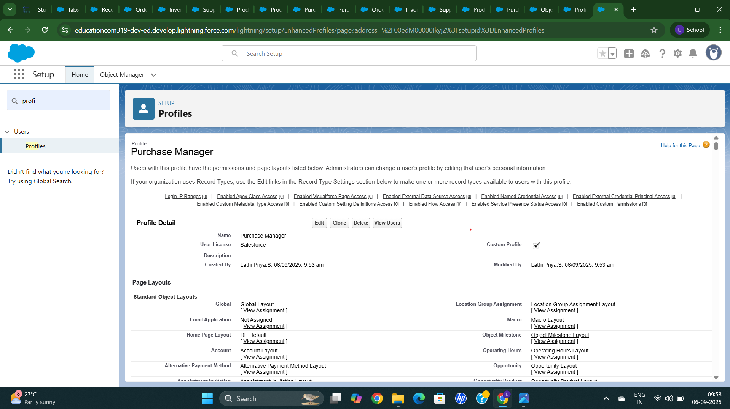

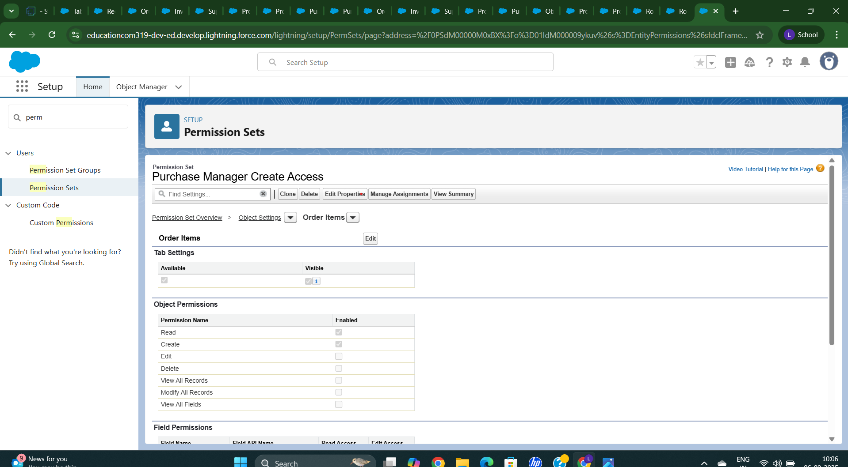

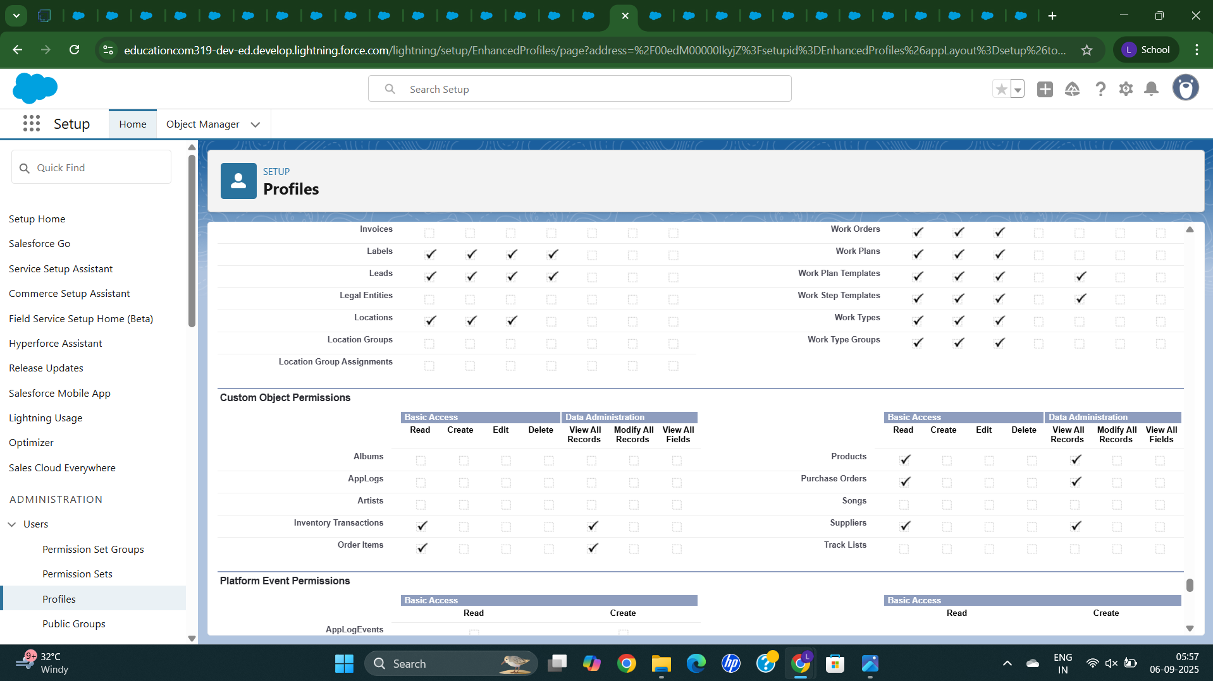

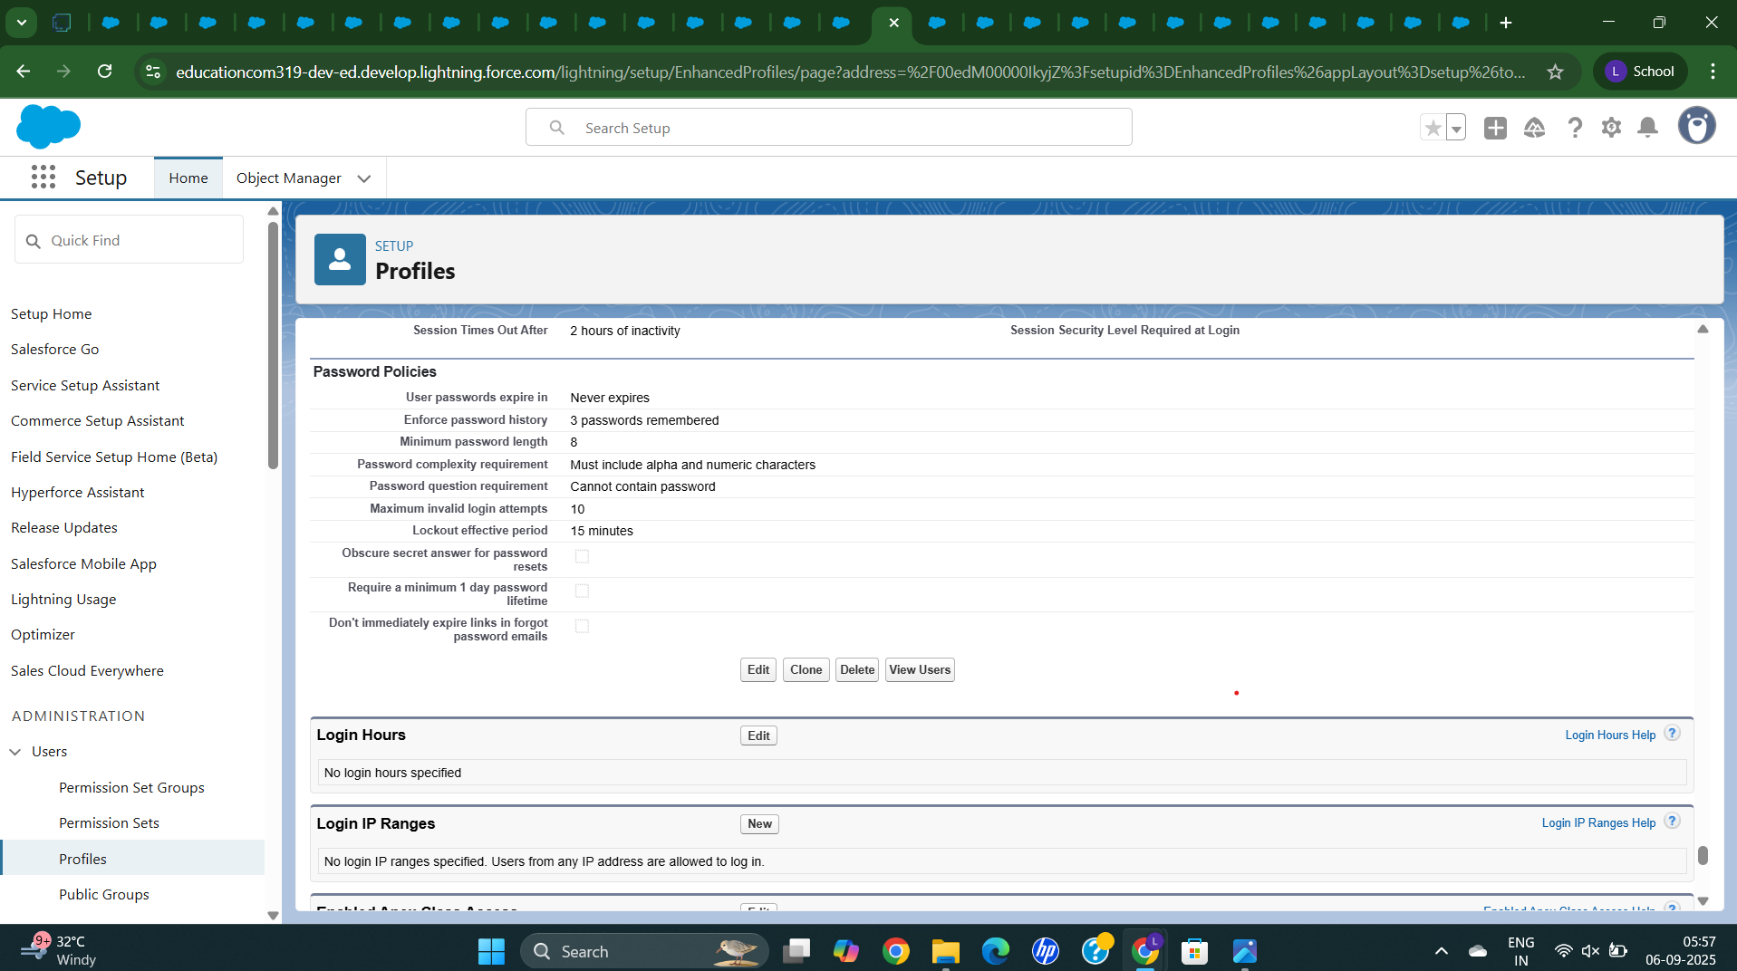

**Create a Role for Purchase Object**

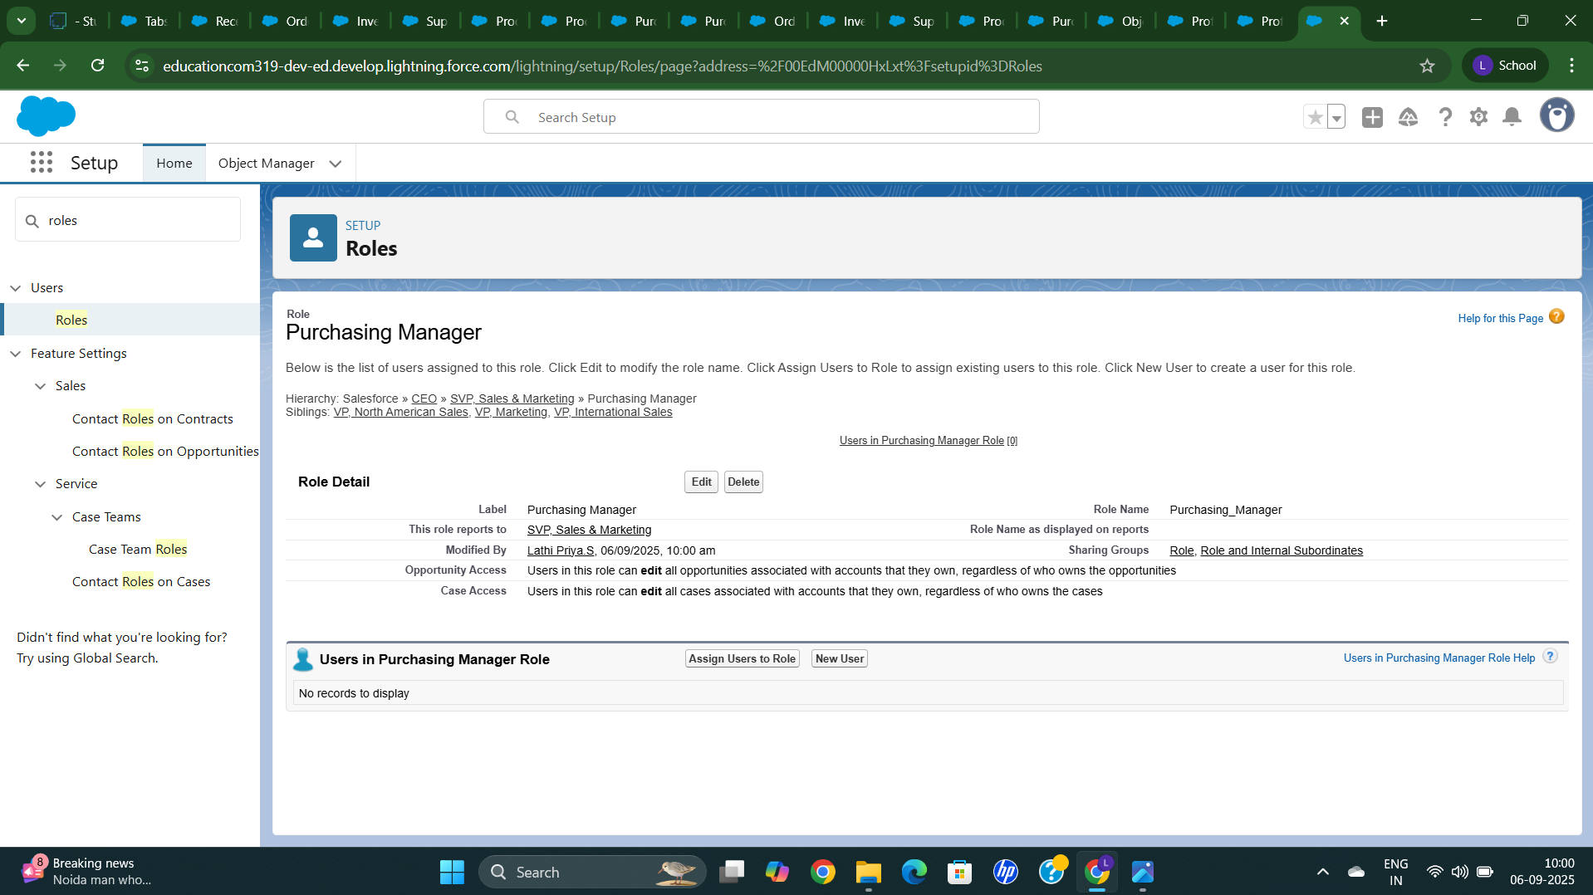

**Create a Role for Inventory Transaction**

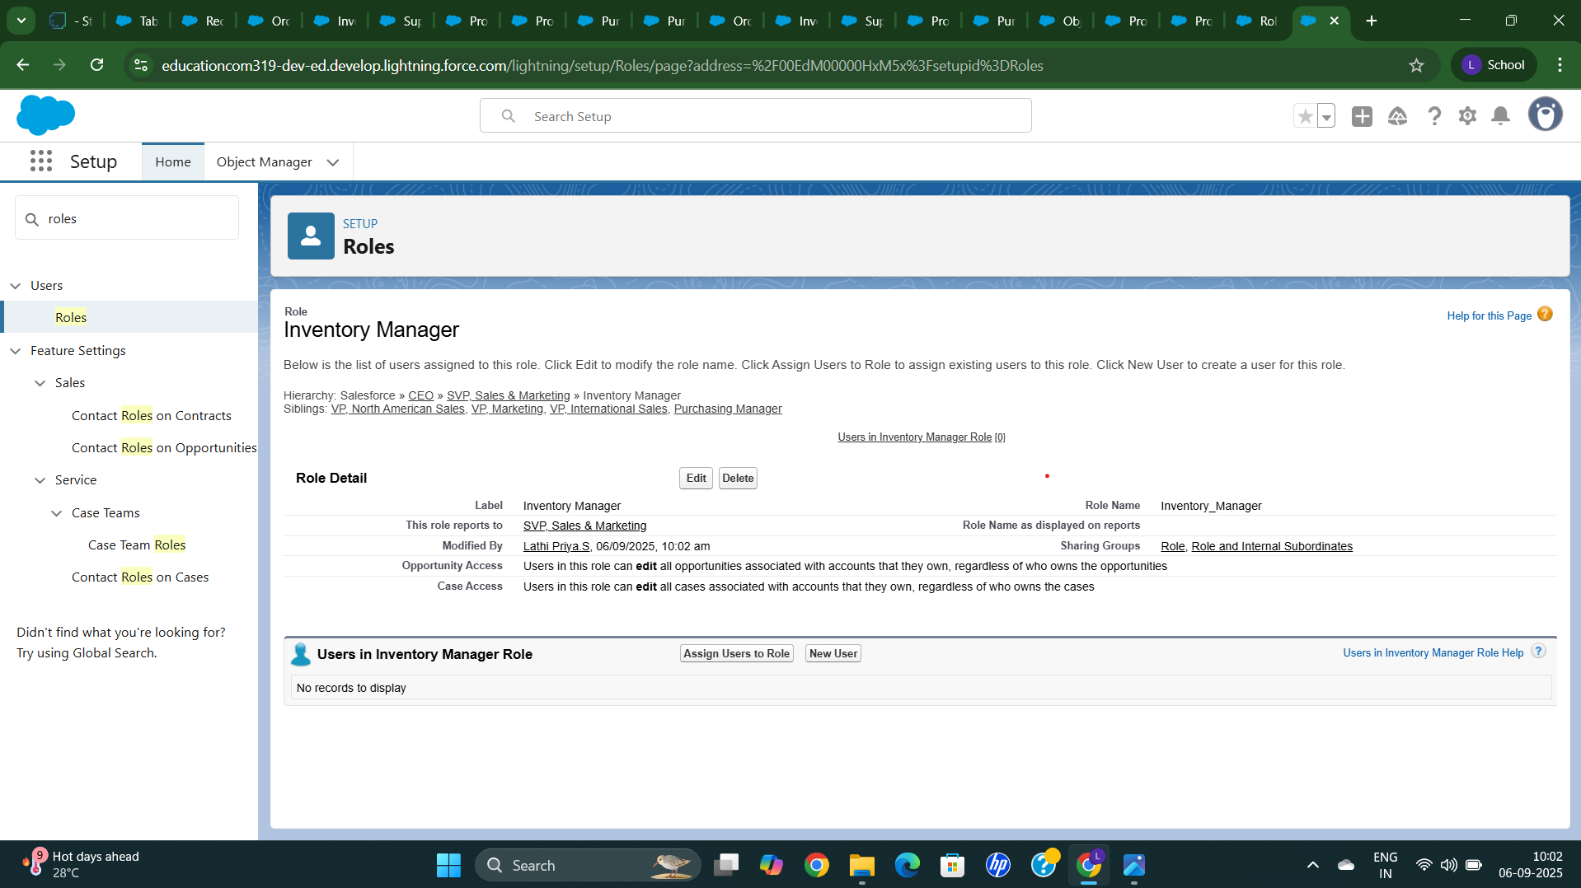

**Create a Permission Set for Purchasing Manager**

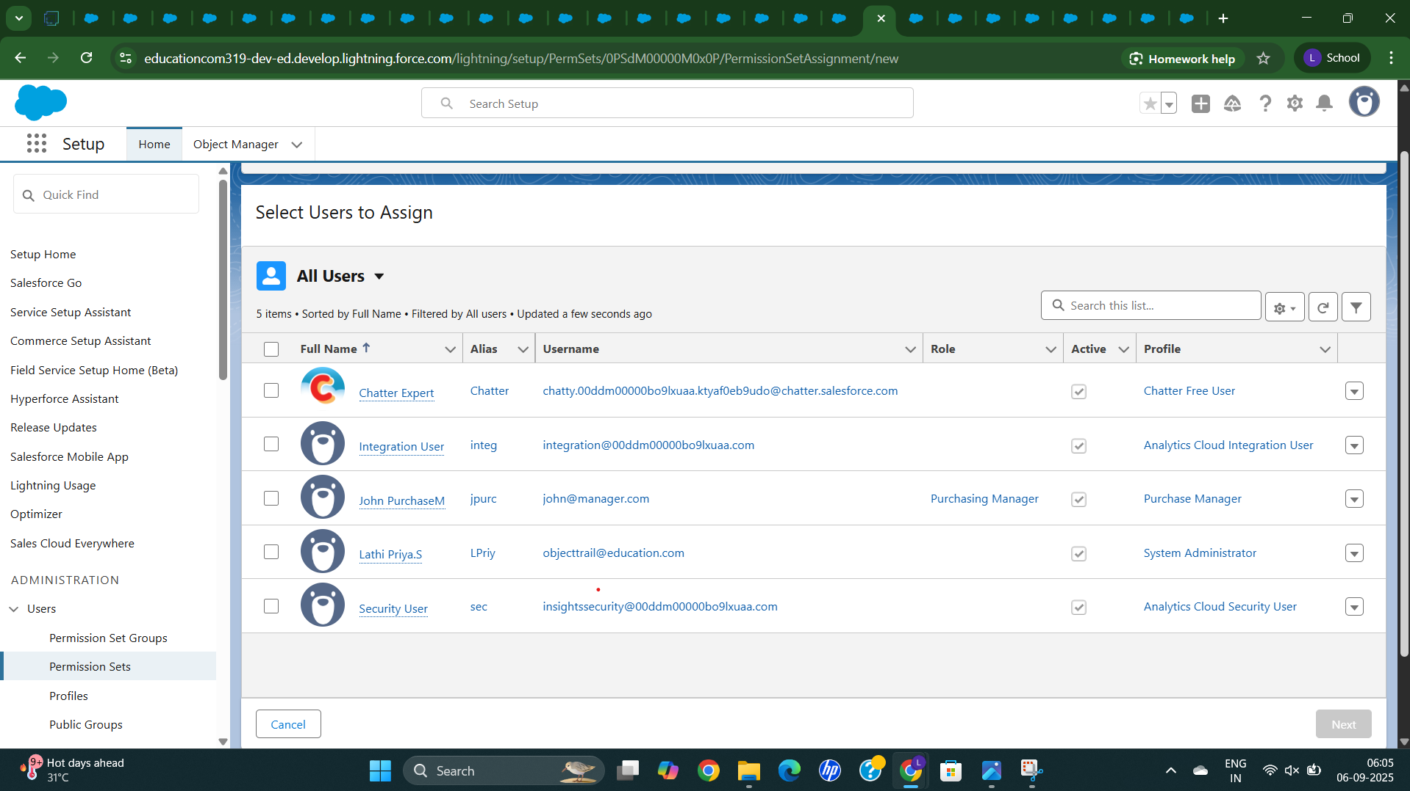

**Giving Access to Purchasing Manager (John PurchaseM)**

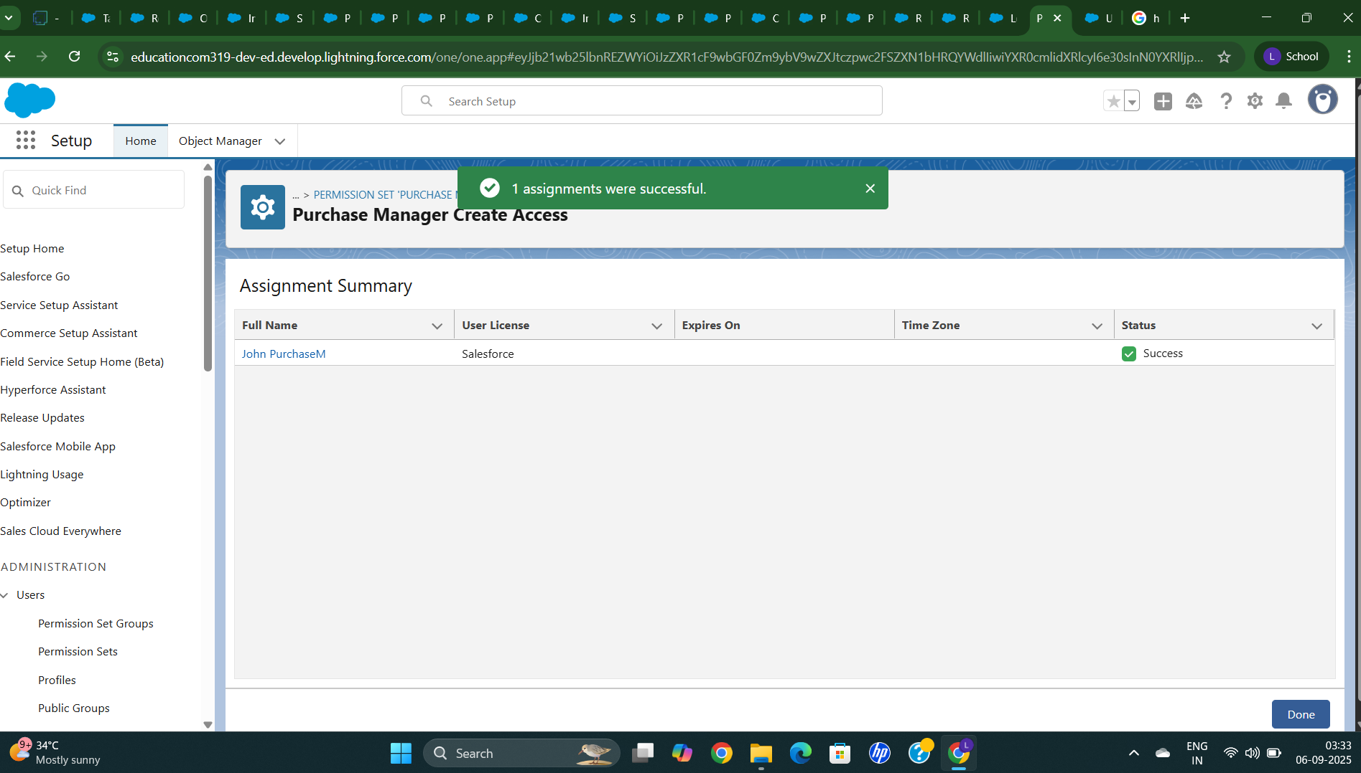

**Create a Flow to Update the Delivery Date**

**First we created a Get Purchase Records**

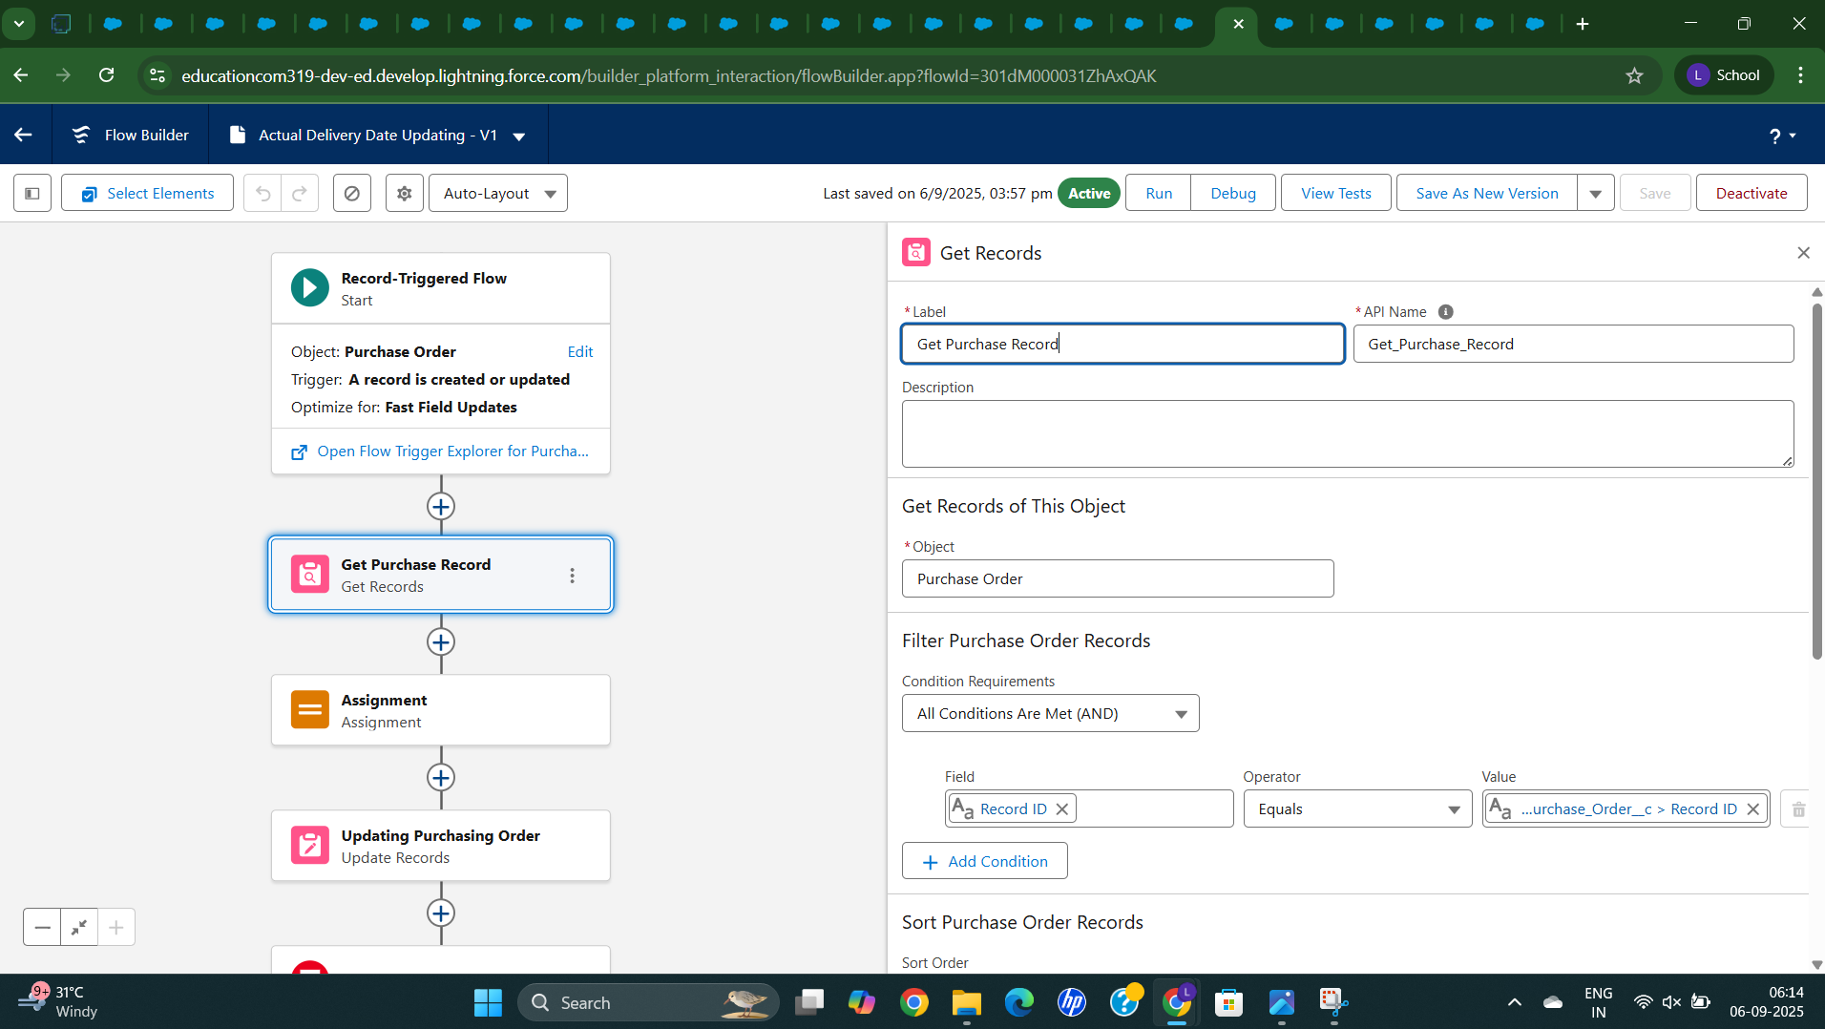**here we add a Assignment flow**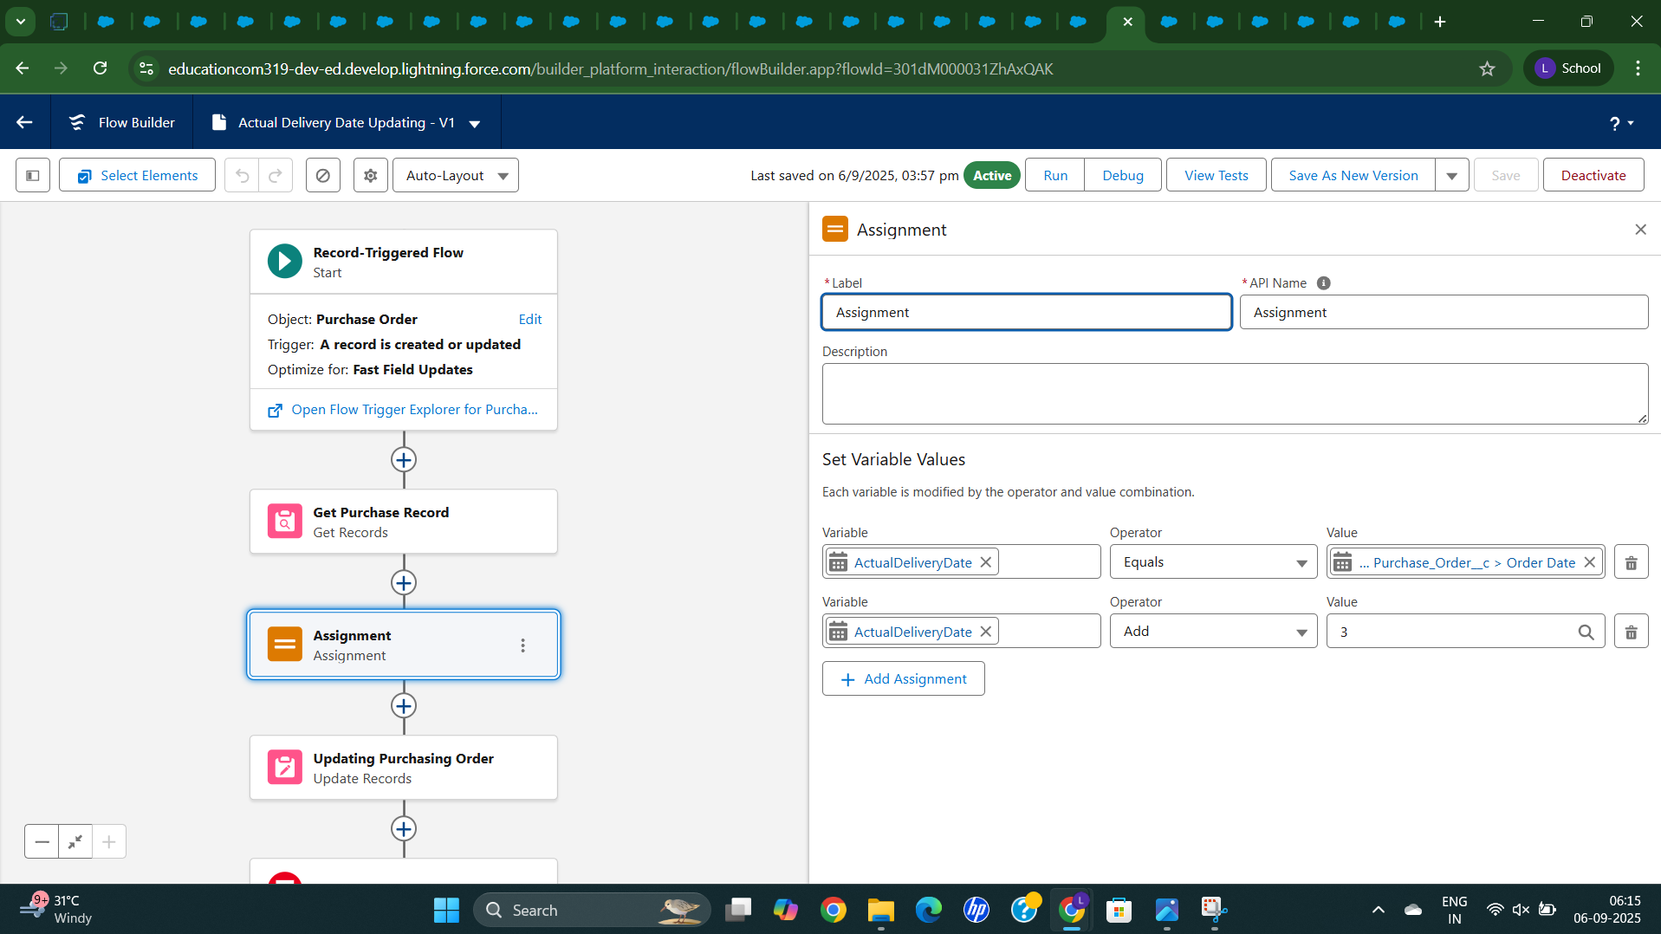

**After adding a Assignment flow we add Updating Purchasing Order**

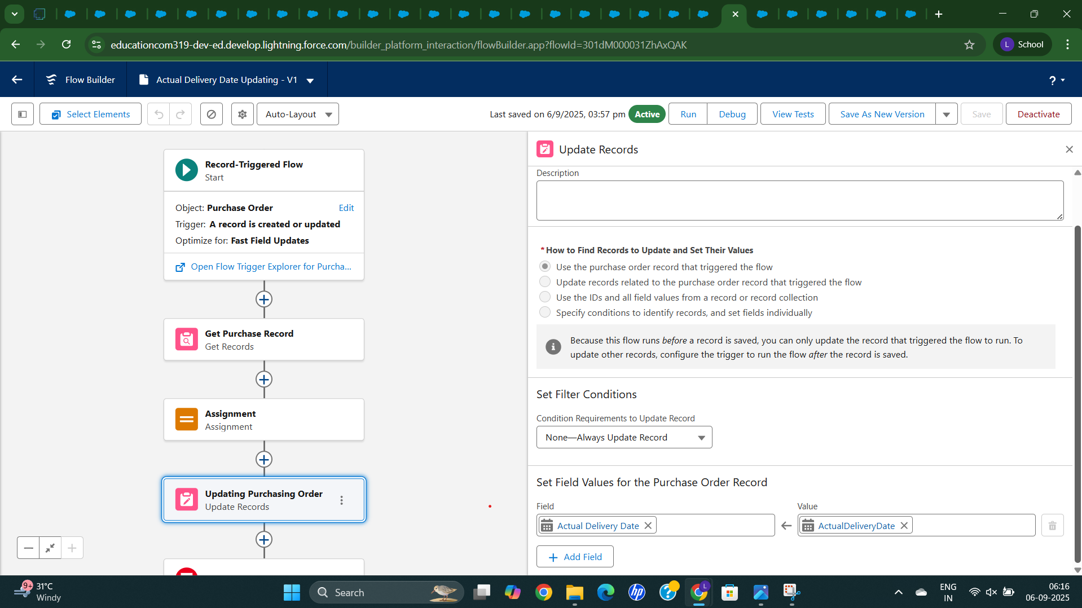

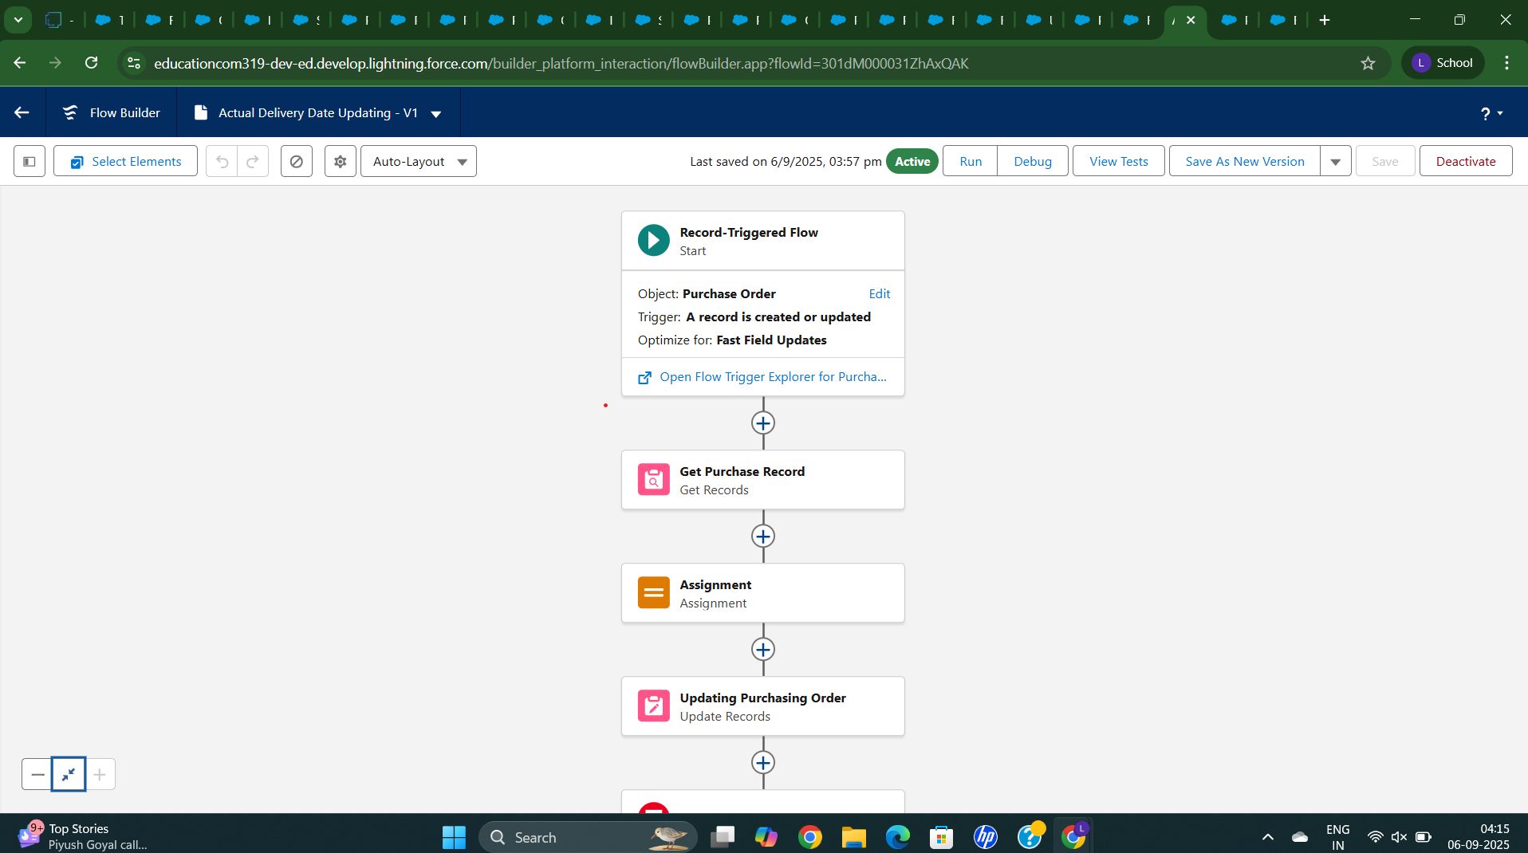

**Creating a Triggers in Developer Console**

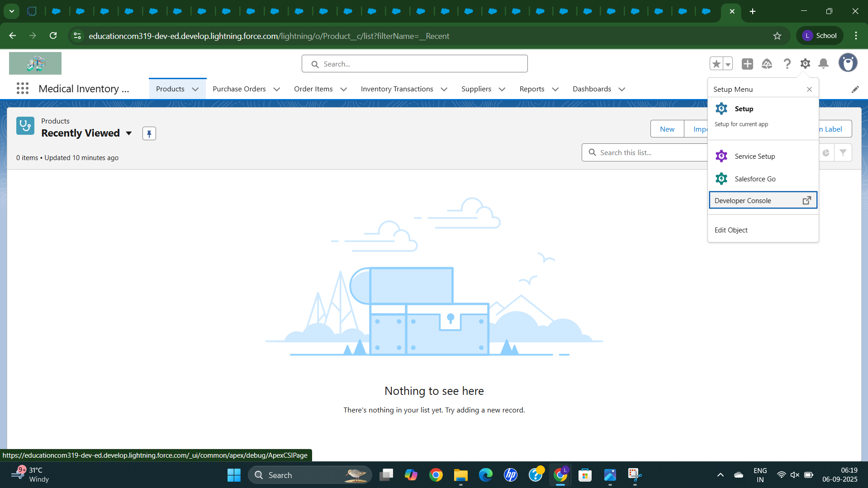

**Creating a New Triggers**

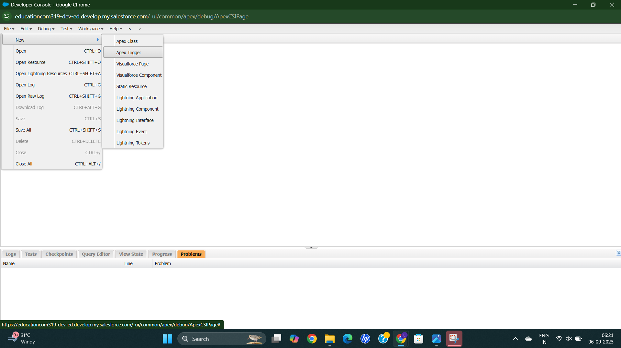

**Creating a Triggers Class as CalculateTotalAmountTrigger**

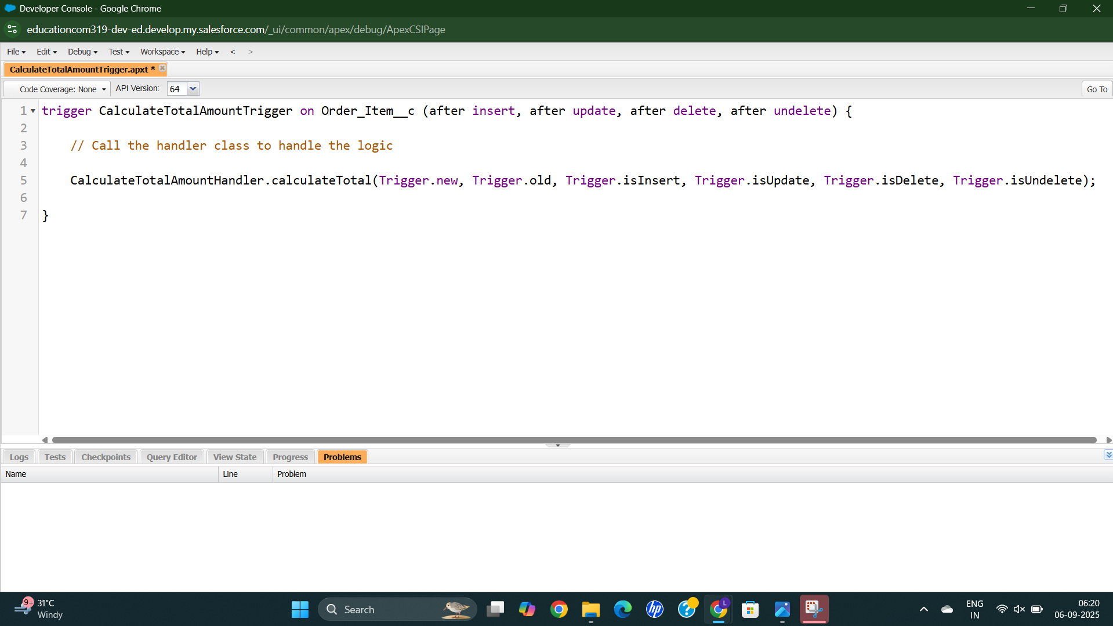

**Creating a Class as CalculateTotalAmountHandler**

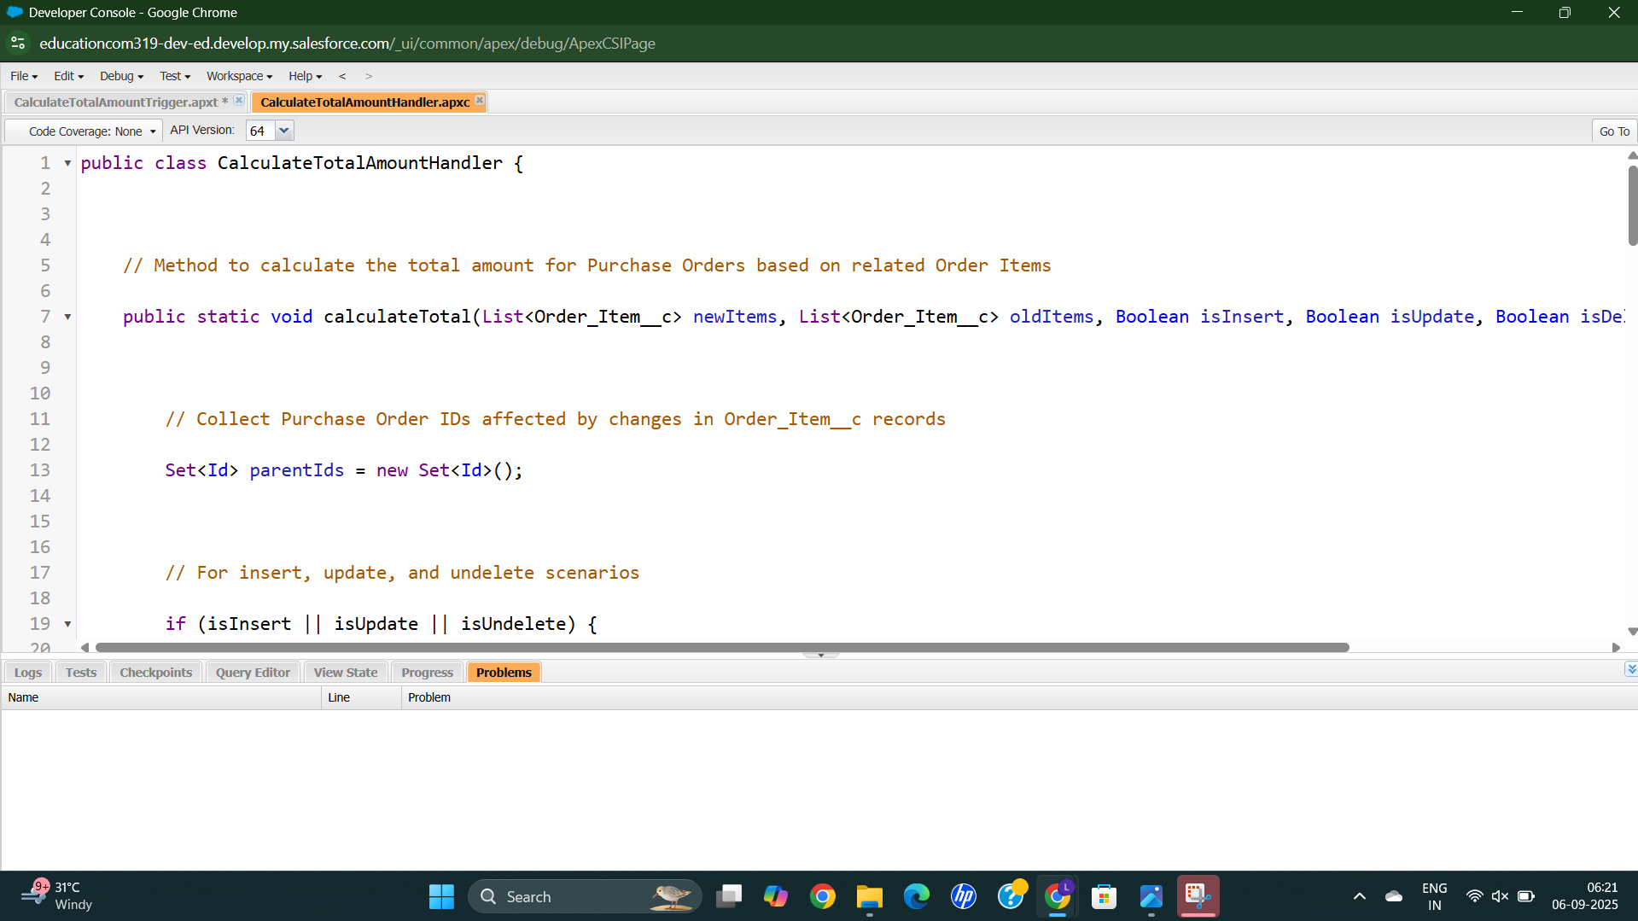

**Testing the Code**

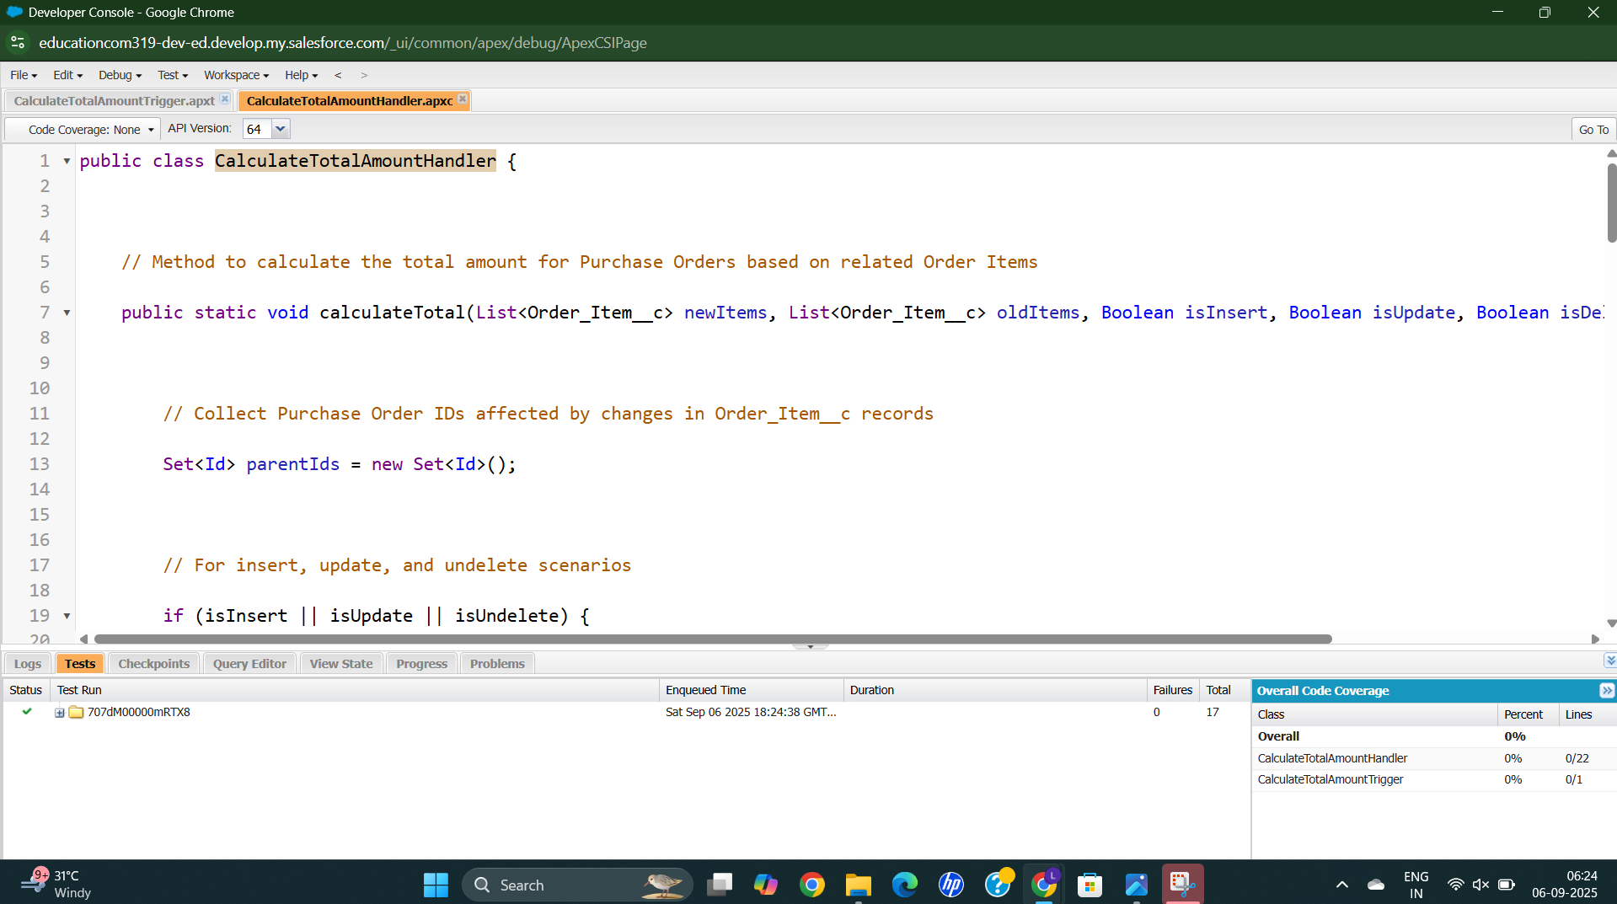

**Create a Purchase Order Based on Supplier Reports**

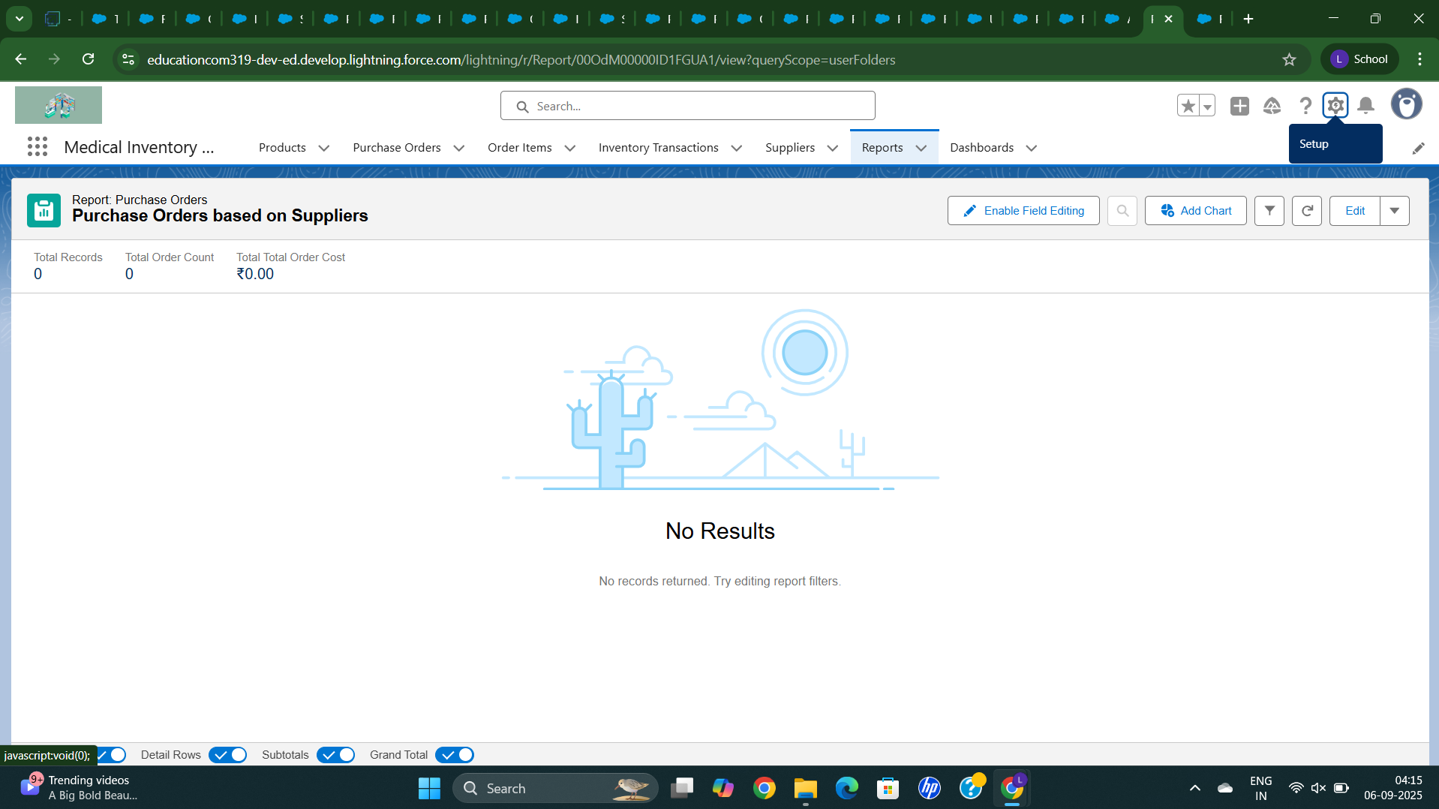

**Here its Empty Orders**

**Now we are creating a Supplier**

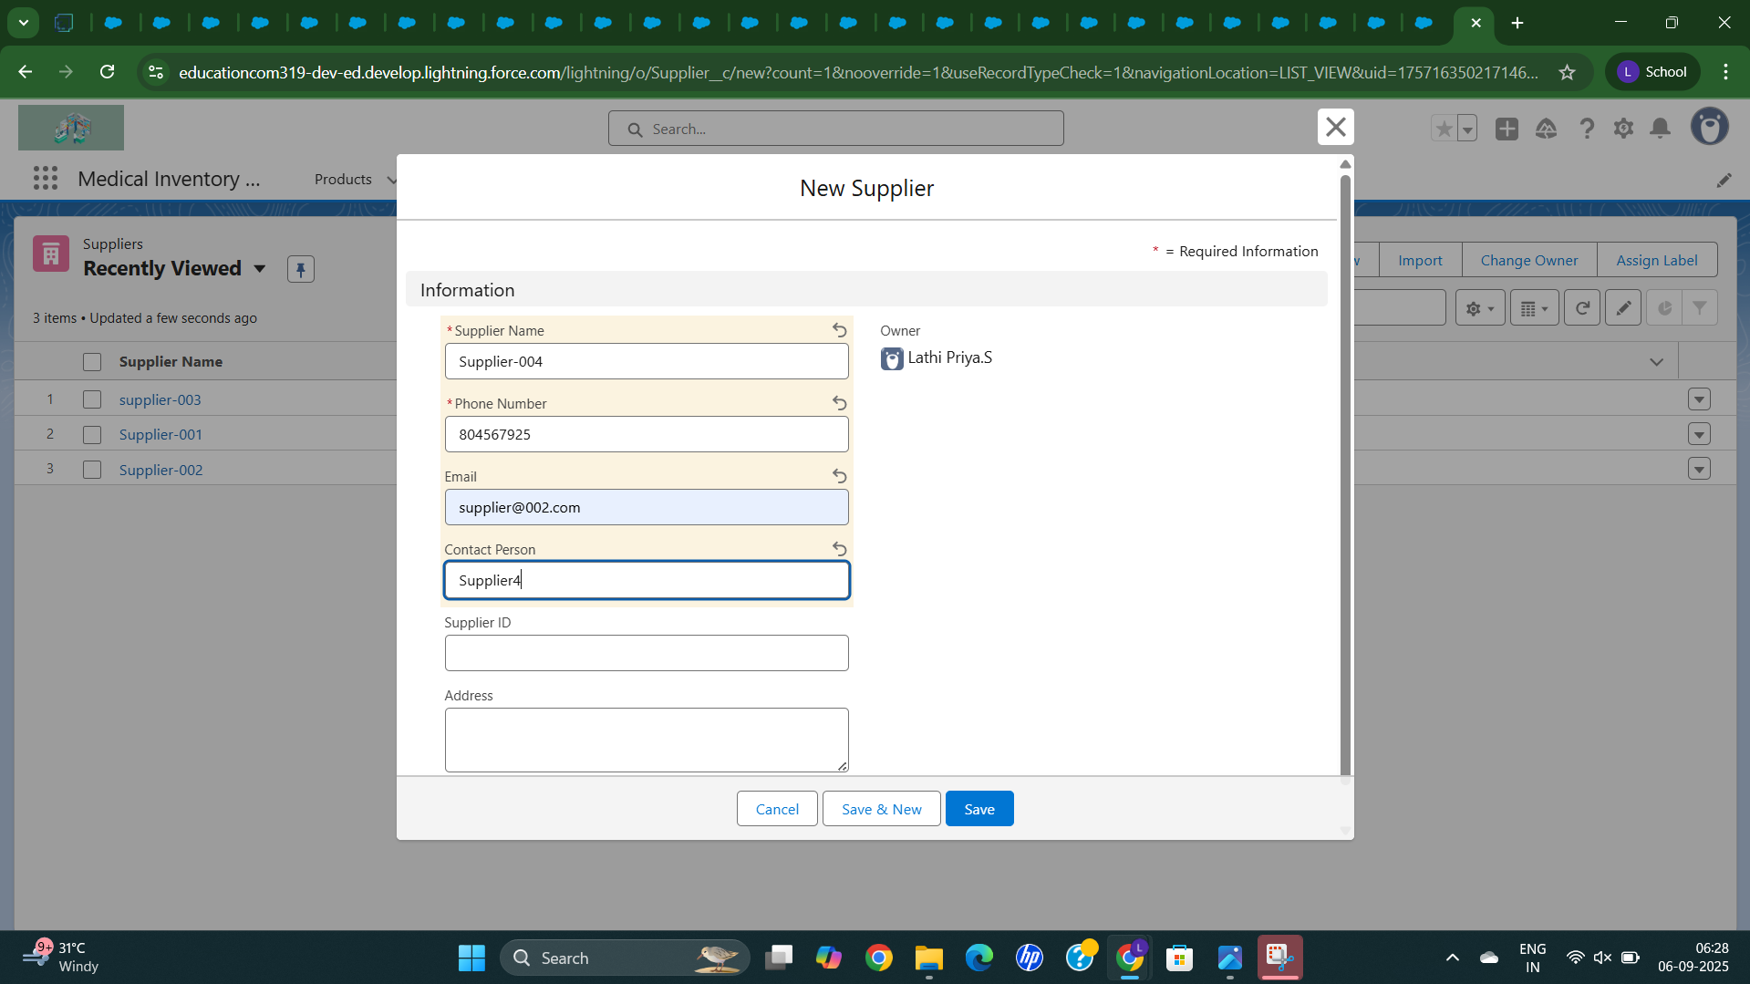

**We have created a Supplier**

**And then we are adding a purchase Order**

**In Supplier itself by clicking a Related tab**

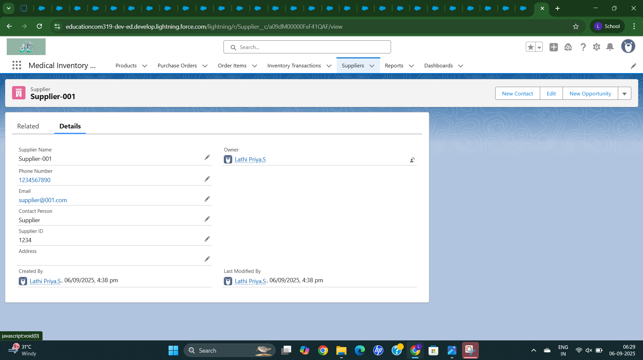

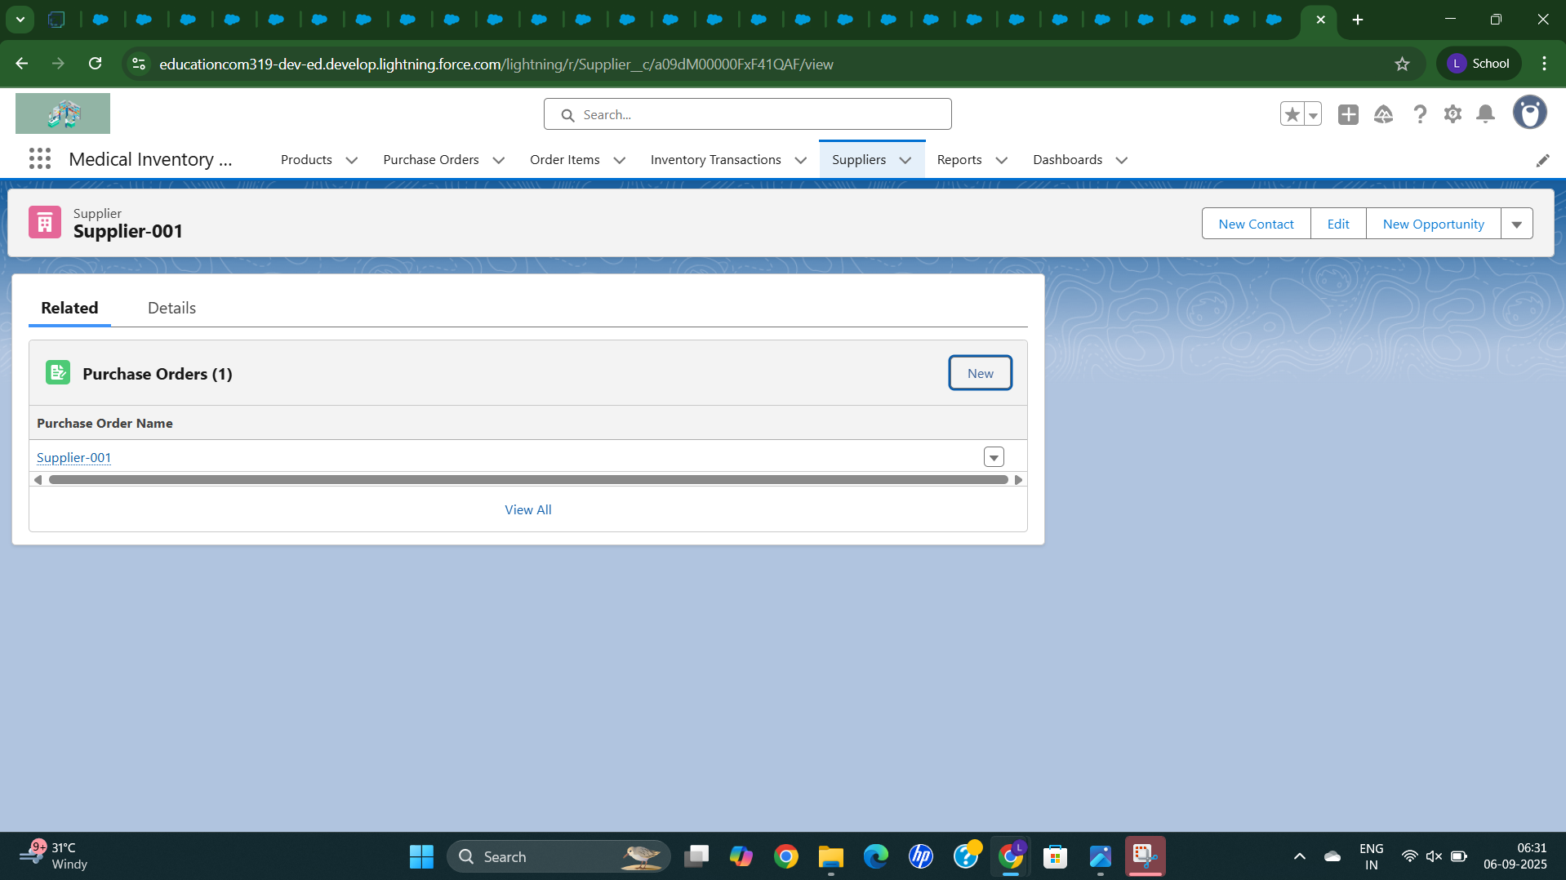

**We have created one purchase Order**

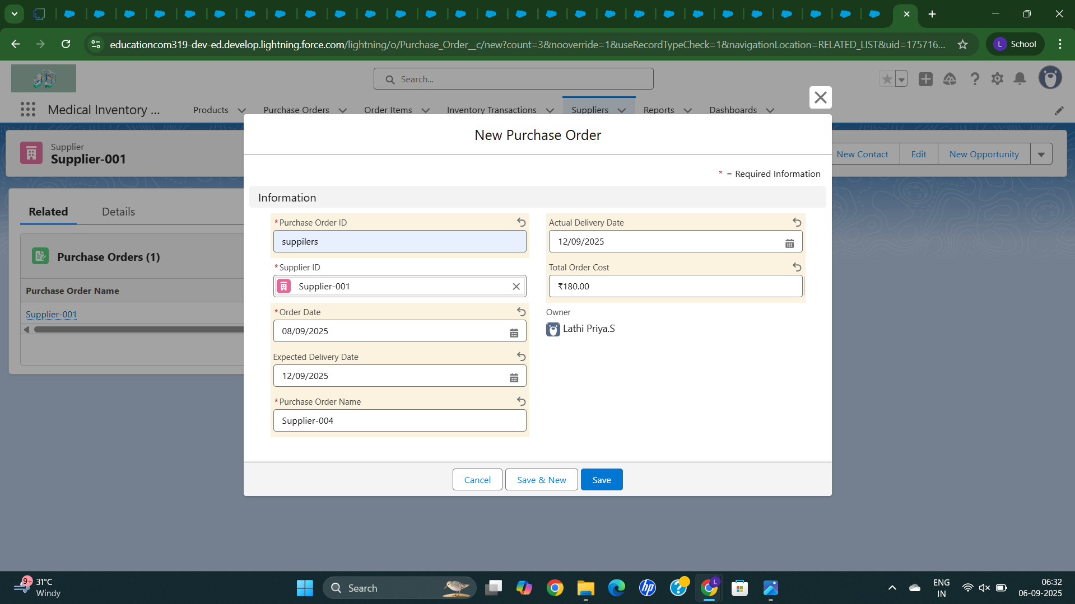

**It is displayed in Purchase Order**

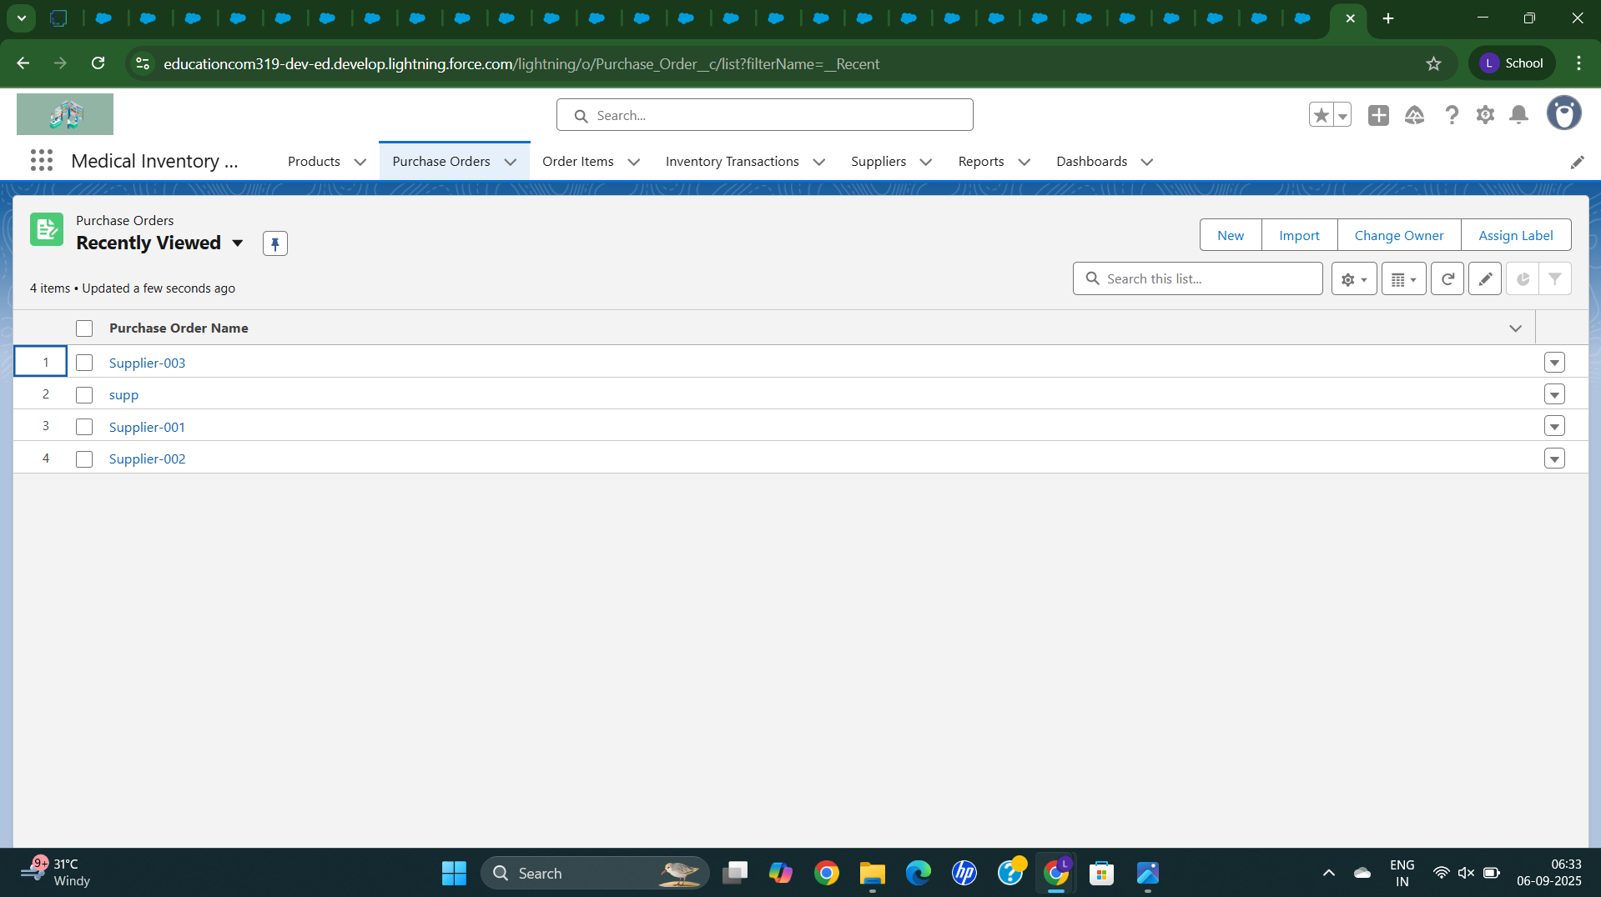

**In Reports it displaying the orders**

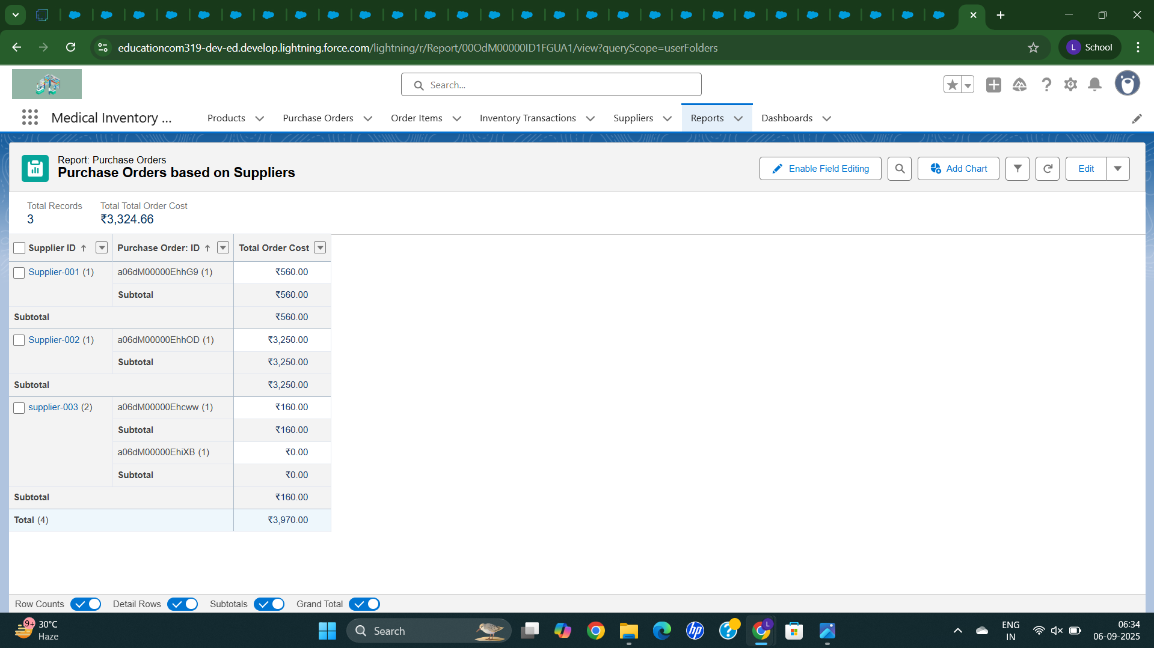

**I have order the item as para**

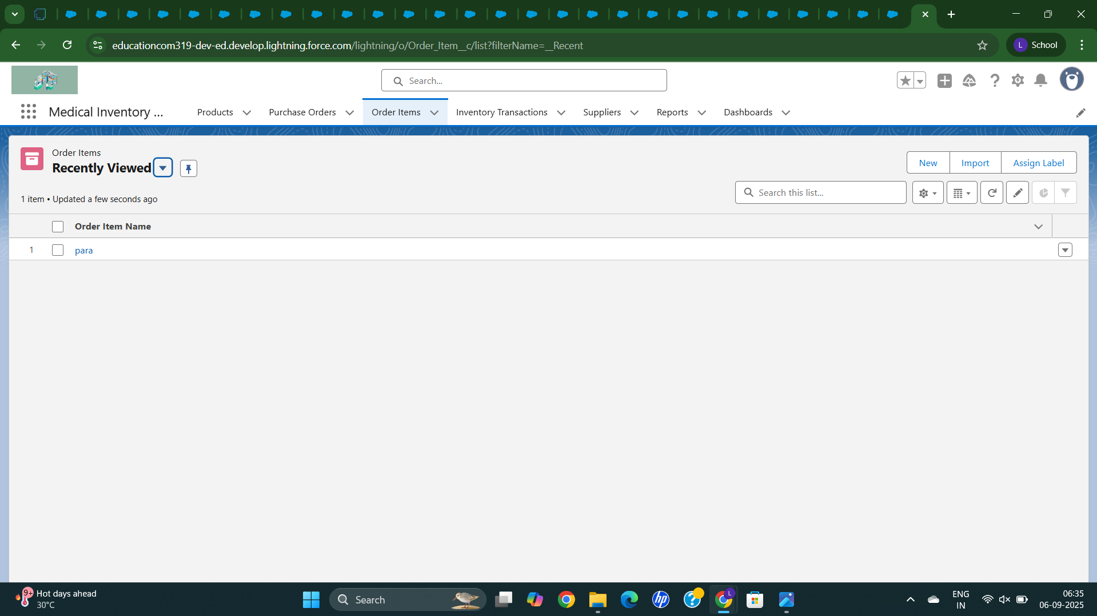

**Creating a Dashboard**

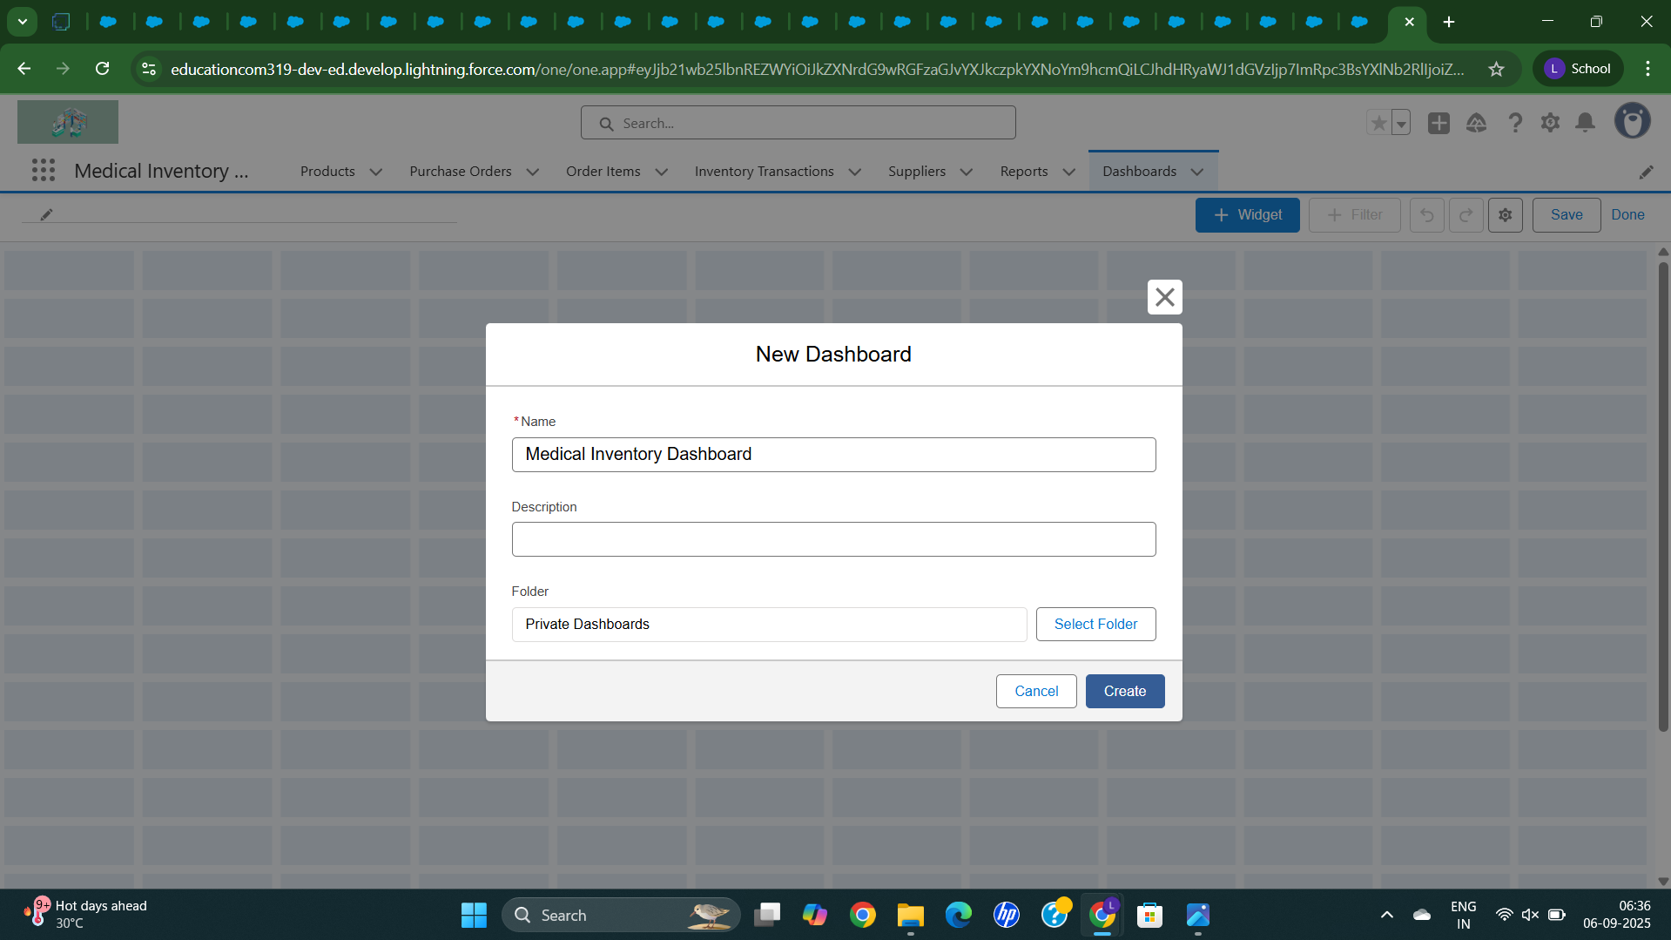

**Now we are choosing the Widgets**

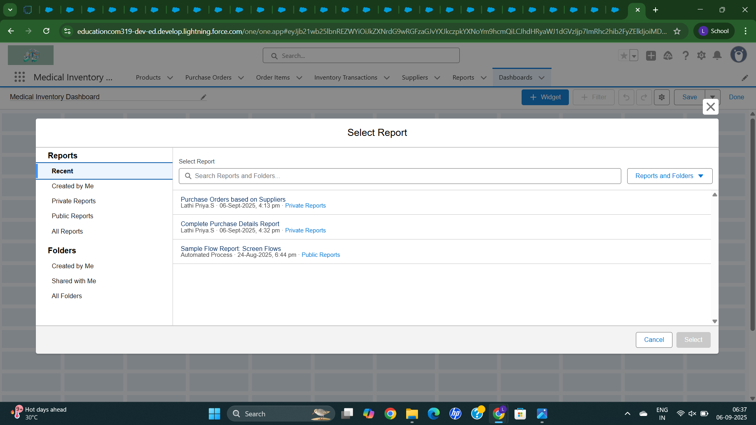

**Now Choosing a Charts to display**

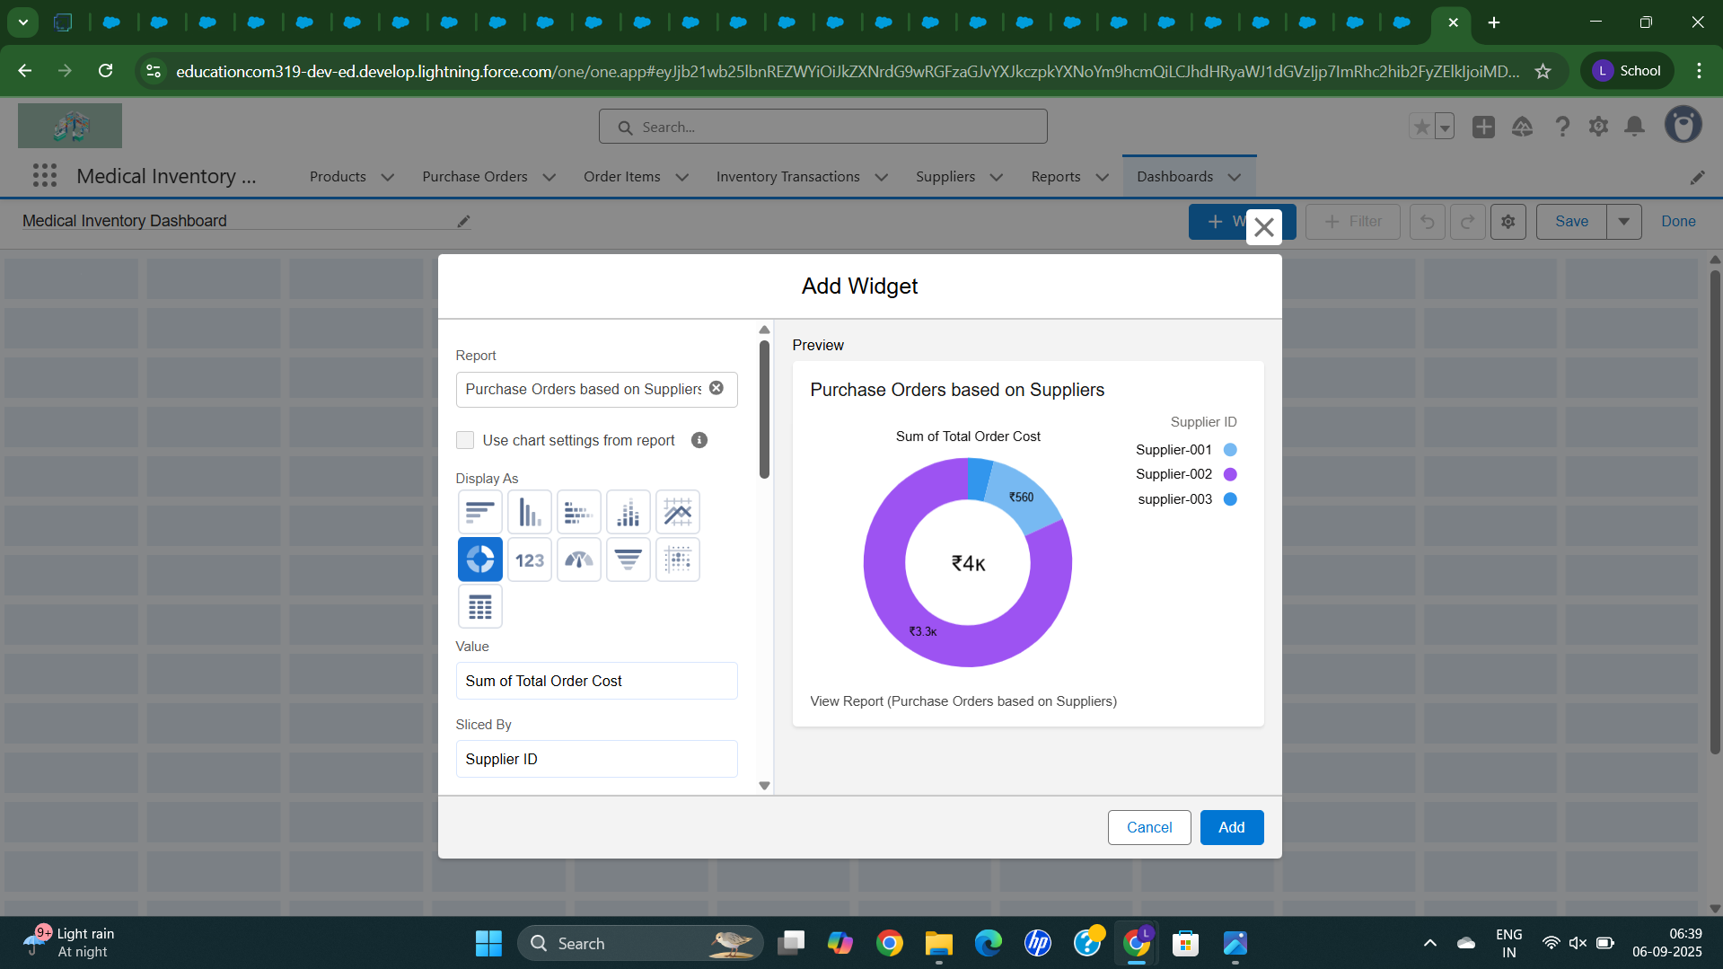

**The dashboard is created as Medical Inventory DashBoard**

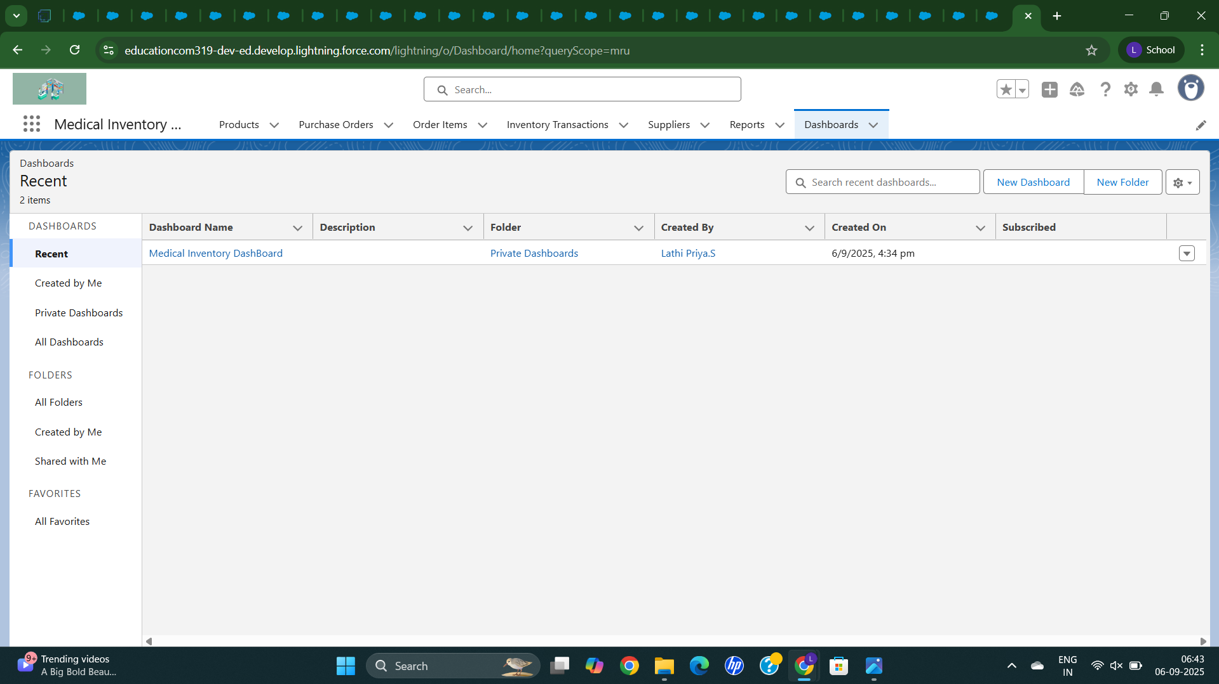

**The Chart that we created for this DashBoard**

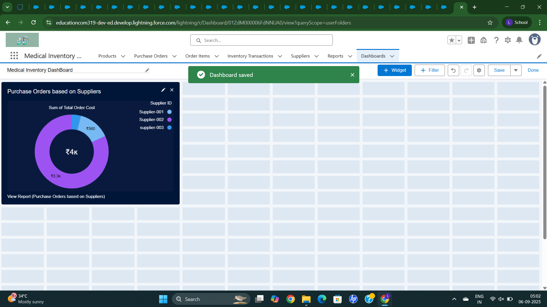

**These are the items purchased**

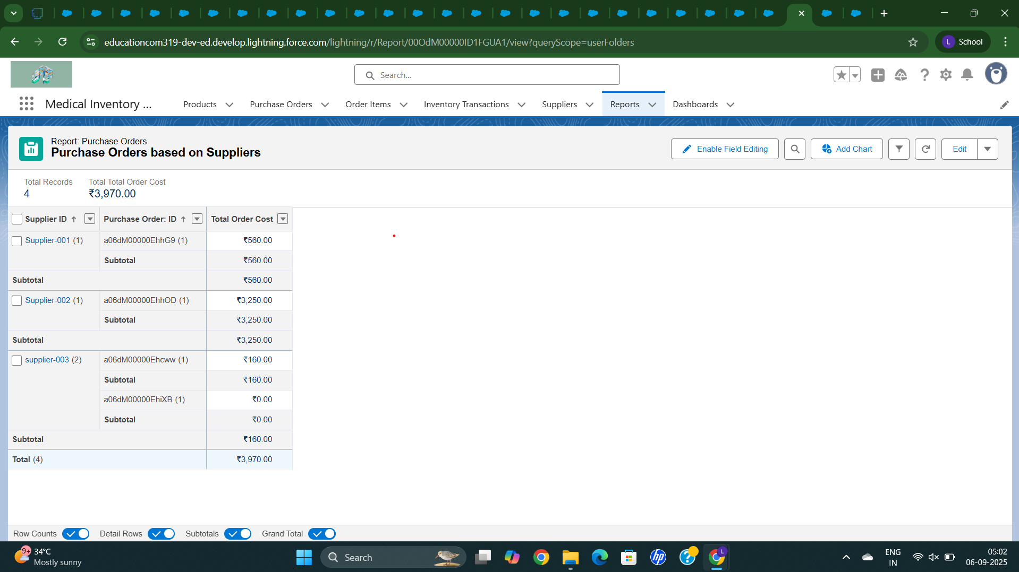

**Now purchased item will display in dashboard**

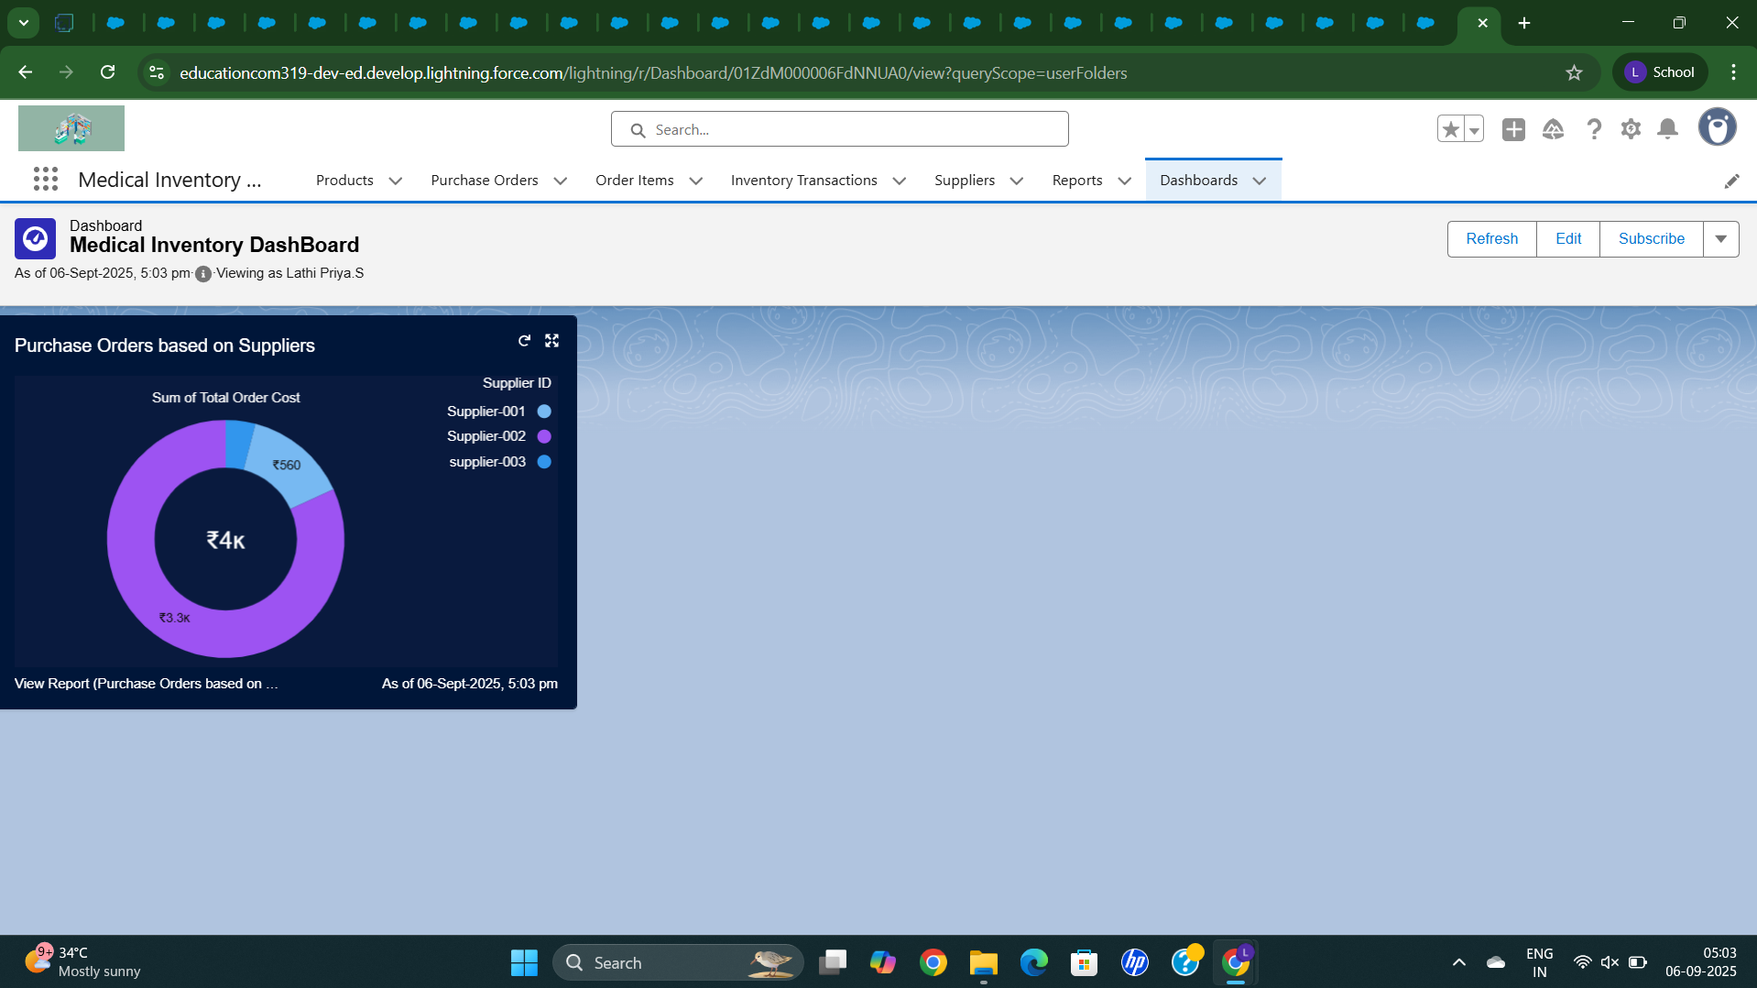

**CONCLUSION:**

The Medical Inventory Management each milestone contributes to enhancing the system’s efficiency and usability — Starting from account creation to building objects, fields, and layouts, and then moving towards automation with flows and triggers, the app is now well-structured, secure with proper profiles and roles, and provides clear insights through reports and dashboards. This ensures that the end-user gets a simple, efficient, and reliable system to manage their requirements effectively.

**APPENDIX**

**Triggers Class :**

**CalculateTotalAmountTrigger.apxt**

trigger CalculateTotalAmountTrigger on Order_Item__c (after insert, after update, after delete, after undelete) {

// Call the handler class to handle the logic

CalculateTotalAmountHandler.calculateTotal(Trigger.new, Trigger.old, Trigger.isInsert, Trigger.isUpdate, Trigger.isDelete, Trigger.isUndelete);

}

**APEX CLASS:**

**CalculateTotalAmountHandler.apxc**

public class CalculateTotalAmountHandler {

// Method to calculate the total amount for Purchase Orders based on related Order Items

public static void calculateTotal(List<Order_Item__c> newItems, List<Order_Item__c> oldItems, Boolean isInsert, Boolean isUpdate, Boolean isDelete, Boolean isUndelete) {

// Collect Purchase Order IDs affected by changes in Order_Item__c records

Set<Id> parentIds = new Set<Id>();

// For insert, update, and undelete scenarios

if (isInsert || isUpdate || isUndelete) {

for (Order_Item__c ordItem : newItems) {

parentIds.add(ordItem.Purchase_Order_Id__c);

}

}

// For update and delete scenarios

if (isUpdate || isDelete) {

for (Order_Item__c ordItem : oldItems) {

parentIds.add(ordItem.Purchase_Order_Id__c);

}

}

// Calculate the total amounts for affected Purchase Orders

Map<Id, Decimal> purchaseToUpdateMap = new Map<Id, Decimal>();

if (!parentIds.isEmpty()) {

// Perform an aggregate query to sum the Amount__c for each Purchase Order

List<AggregateResult> aggrList = [

SELECT Purchase_Order_Id__c, SUM(Amount__c) totalAmount

FROM Order_Item__c

WHERE Purchase_Order_Id__c IN :parentIds

GROUP BY Purchase_Order_Id__c

];

// Map the result to Purchase Order IDs

for (AggregateResult aggr : aggrList) {

Id purchaseOrderId = (Id)aggr.get('Purchase_Order_Id__c');

Decimal totalAmount = (Decimal)aggr.get('totalAmount');

purchaseToUpdateMap.put(purchaseOrderId, totalAmount);

}

// Prepare Purchase Order records for update

List<Purchase_Order__c> purchaseToUpdate = new List<Purchase_Order__c>();

for (Id purchaseOrderId : purchaseToUpdateMap.keySet()) {

Purchase_Order__c purchaseOrder = new Purchase_Order__c(Id = purchaseOrderId, Total_Order_cost__c = purchaseToUpdateMap.get(purchaseOrderId));

purchaseToUpdate.add(purchaseOrder);

}

// Update Purchase Orders if there are any changes

if (!purchaseToUpdate.isEmpty()) {

update purchaseToUpdate;

}

}

}

}